Dear Students,

For your project, please prepare **one PDF file** report containing the following elements. Make sure to include all of the elements – No further report submissions will be allowed.

1. Current status of the project implementation:
   * List of fully implemented use-cases / functionalities
   * List of partially implemented use-cases / functionalities. Give the percentage of implementation.
   * List of use-cases that have not been implemented.
2. Team member contributions.
   * For every team member detail the list of accomplished tasks by the member, **and** the overall contribution percentage to the project (%).
   * Team coordination: describe in a concise way how the team members collaborated to achieve the project. List the collaboration tools that you have used, if any.
3. Visual overview of the project. Walk the report reader with your application by providing pictures of various pages and use cases as well as the control flow between pages.
4. Design diagrams: Give all the design diagrams that you have established: control flow (for pages), entities, etc.
5. For verification, provide the source code of your project in one of the following ways:
   * Share your project with me on Github
   * Provide a link to download a zipped folder containing your (e.g. through google drive).
6. Use the template below for your reports

**Send your report by email to** [**mbarhamgi@qu.edu.qa**](mailto:mbarhamgi@qu.edu.qa) **and CC barhamgi@gmail.com**

Thank you  
Good luck with your projects.

|  |  |  |
| --- | --- | --- |
|  | **CMPS 350 Project Phase 1 – WebApp UI Design and Implementation**  **Conference Management System (ConfPlus)**  **(20% of the course grade)** | |
| **Group Members:** | | Ahmed Ahmed (201907019)  Mohammed Al-Qeraisi (201909907)  Abdelbari Kecita (StudentId) Mustafa Hussein (201906257)  **Emails:** student1@student.qu.edu.qa; student2@student.qu.edu.qa; student3@student.qu.edu.qa; |

**Grading Rubric - In the Functionality column please specify either: *Working (completed x%)*, *Not Working (completed x%)* or *Not done*.**

|  |  |  |  |  |
| --- | --- | --- | --- | --- |
| **Criteria** | **%** | **Functionality\*** | **Quality of the implementation** | **Your Grade** |
| **Application Design:** Entities, Repositories and Web API class diagrams, flow diagrams | 10% |  |  |  |
| **Complete and correct implementation of the requirements:** | **80%** |  |  |  |
| * Login | 10 |  |  |  |
| * Submit paper | 20 |  |  |  |
| * Review paper | 20 |  |  |  |
| * Create/update conference schedule | 20 |  |  |  |
| * Get conference schedule | 10 |  |  |  |
| **Testing, documentation, and group work:**   * Use screen shots to illustrate your tests. * For every team member detail the list of accomplished tasks by the member, **and** the overall contribution percentage to the project (%). * Team coordination: describe in a concise way how the team members collaborated to achieve the project. List the collaboration tools that you have used, if any   **All of these elements should be reported in the template below** | 10% |  |  |  |
| **Total** | 100 |  |  |  |
| Copying and/or plagiarism or not being able to explain or answer questions about the implementation | -100% |  |  |  |

**\* Possible grading for functionality** - ***Working*** (get 70% of the assigned grade), ***Not*** ***working*** (lose 40% of assigned grade and ***Not done*** (get 0). The remaining grade is assigned to the quality of the implementation.

In case your implementation is not working then 40% of the grade will be lost and the remaining 60% will be determined based on of the code quality and how close your solution to the working implementation.

Solution quality also includes meaningful naming of identifiers (according to Android naming conventions), no redundant code, simple and efficient design, clean implementation without unnecessary files/code, use of comments where necessary, proper code formatting and indentation.

**Marks will be reduced** forcode duplication, poor/inefficient coding practices, poor naming of identifiers, unclean/untidy submission, and unnecessary complex/poor user interface design.

# Current status of the project implementation

List of fully implemented use-cases / functionalities:

* Use Case 1: Login -> everything is working.
* Use Case 2: Submit a paper -> we don’t know if uploading the paper PDF to server working or not.
* Use Case 3: Review paper -> everything is working.
* Use Case 5: Get conference schedule -> everything is working.

List of partially implemented use-cases / functionalities. Give the percentage of implementation.

Not finished

List of use-cases that have not been implemented.

Not finished

# Application Design

# Entities class diagram

# Repositories class diagram

# Web API class diagram

# Testing

Home:  
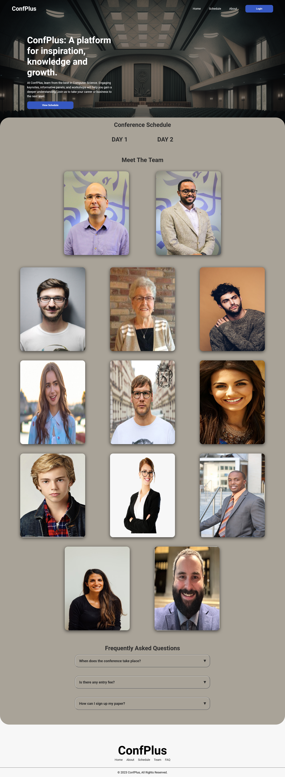

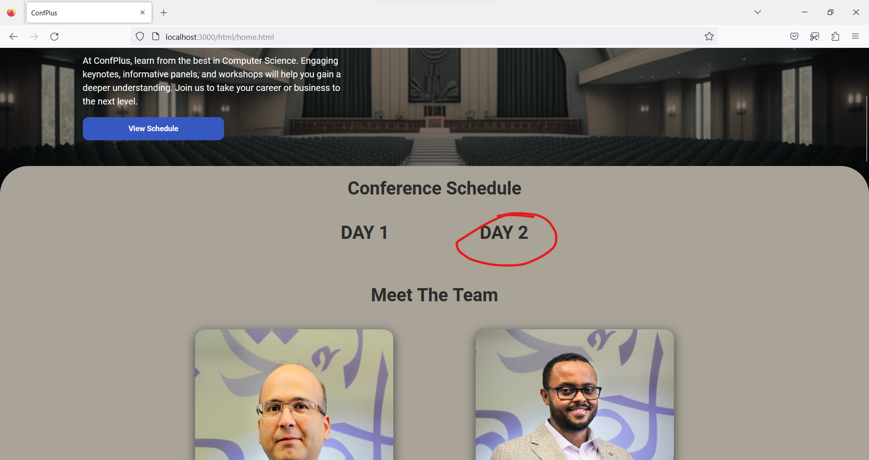



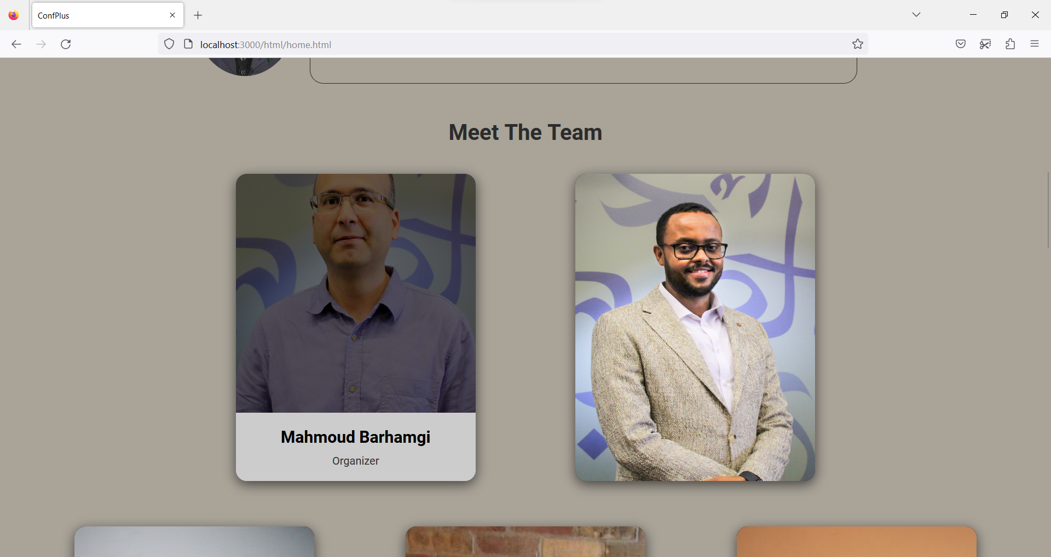

# Login

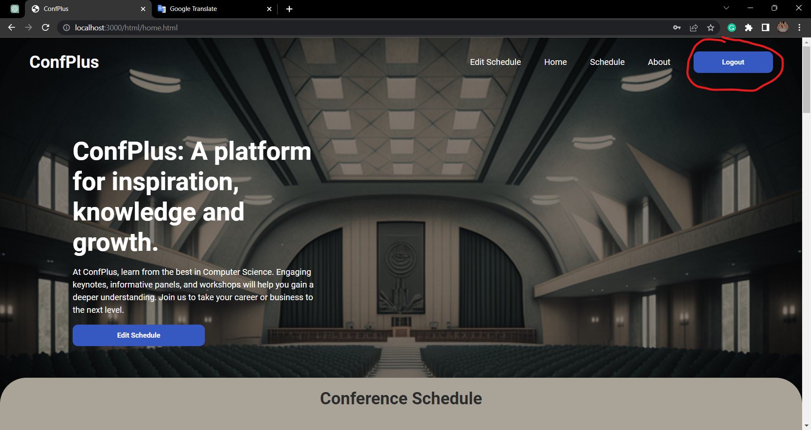

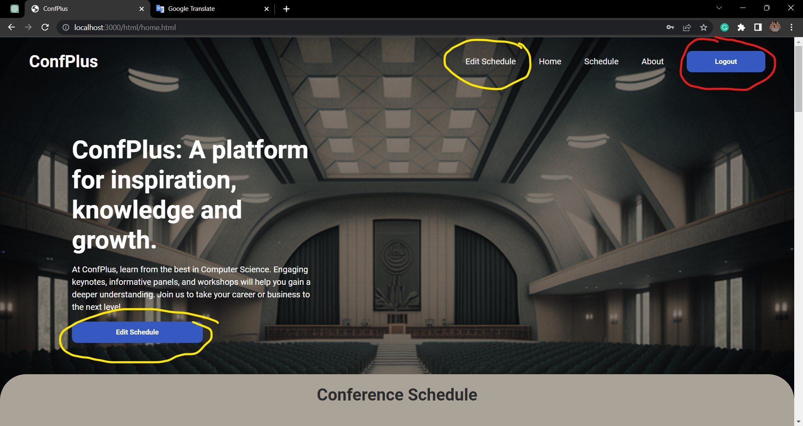

The yellow circle depend on the person's account role ->  
organizer role will show Edit Schedule.  
reviewer role will show Reviewer Paper.  
author role will show Submit Paper.

# Submit paper

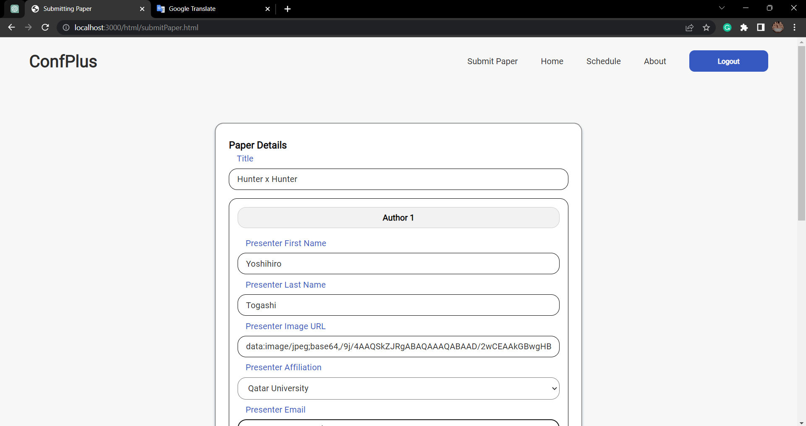

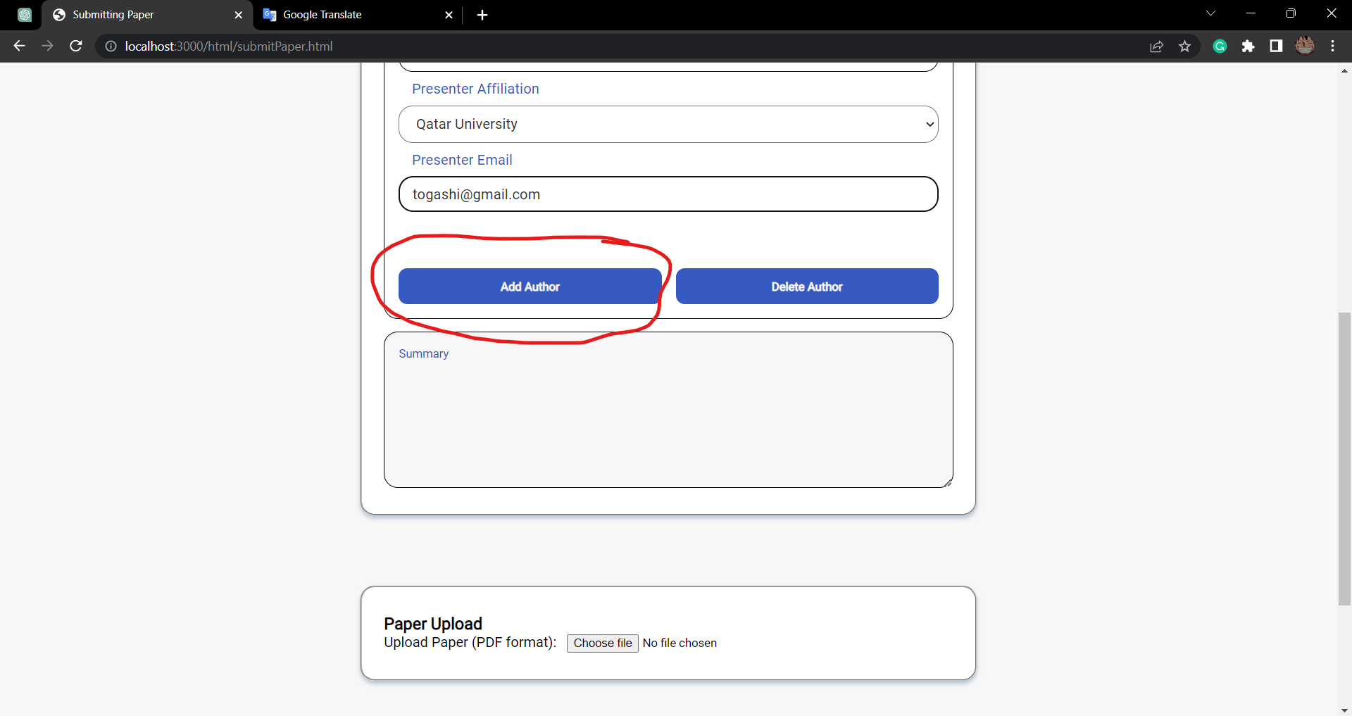

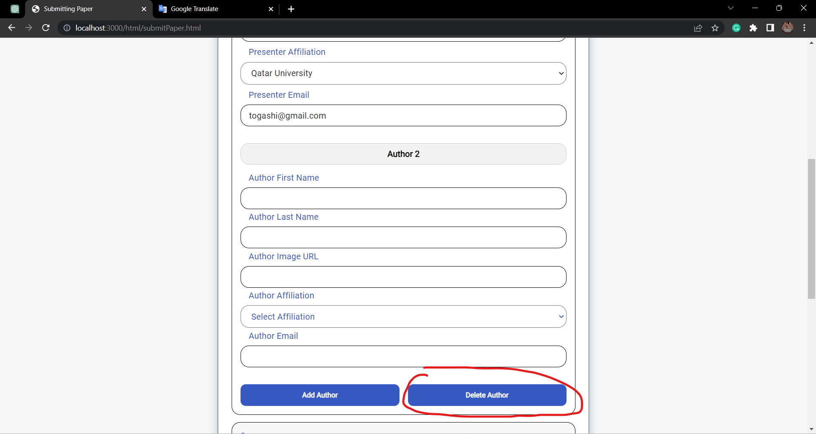

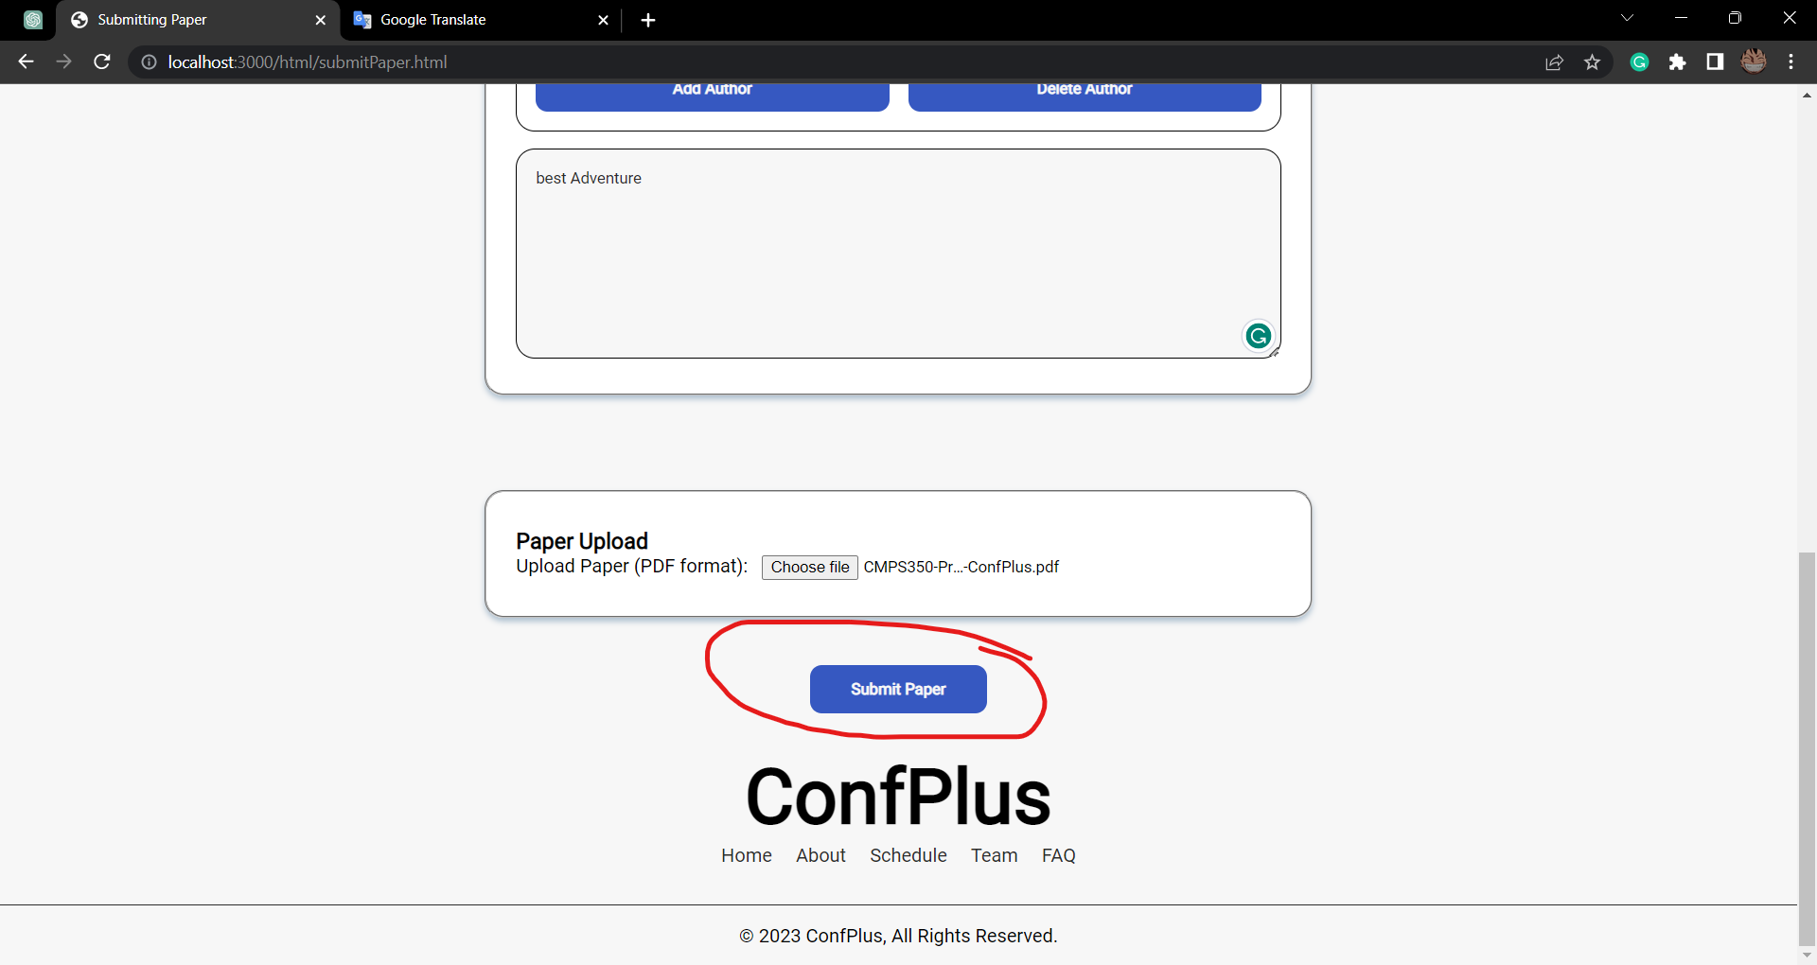

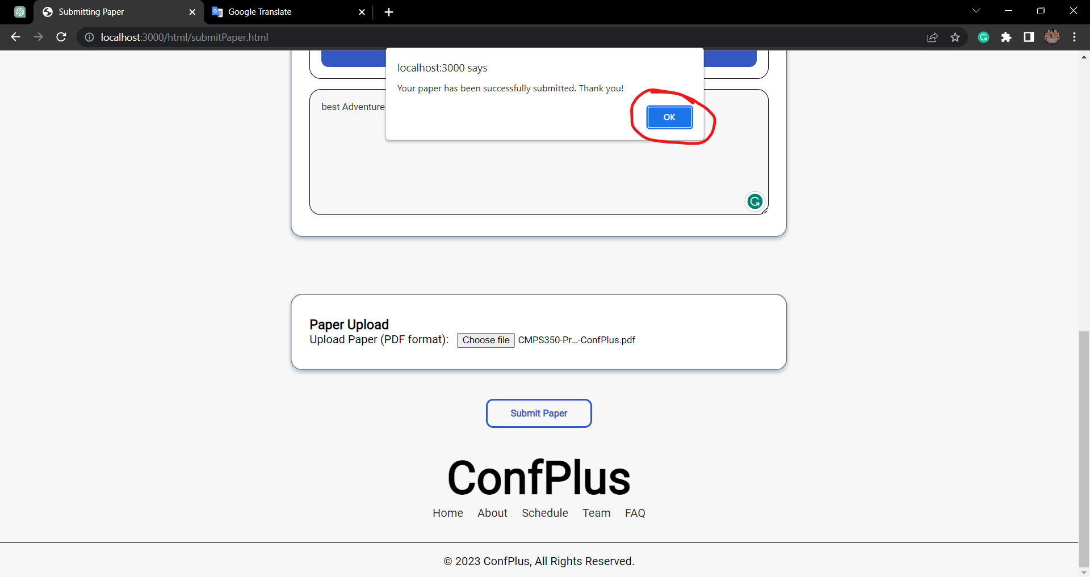

# Review paper

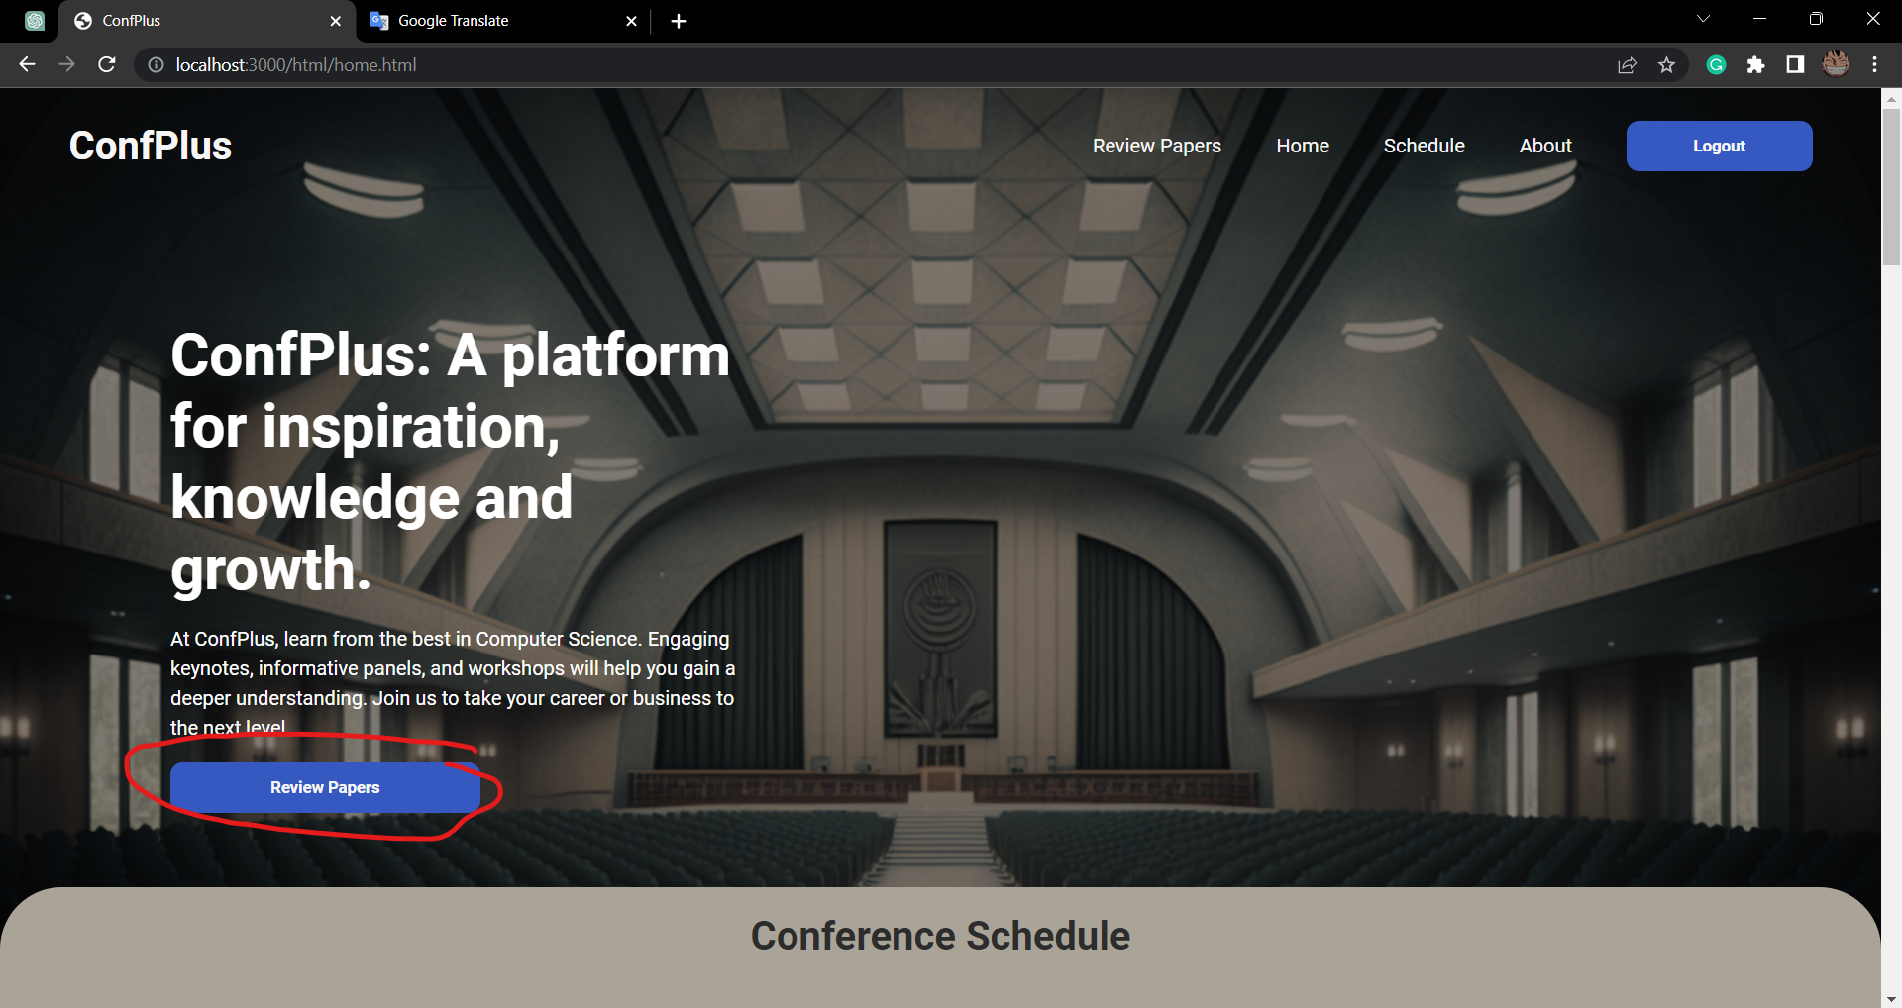

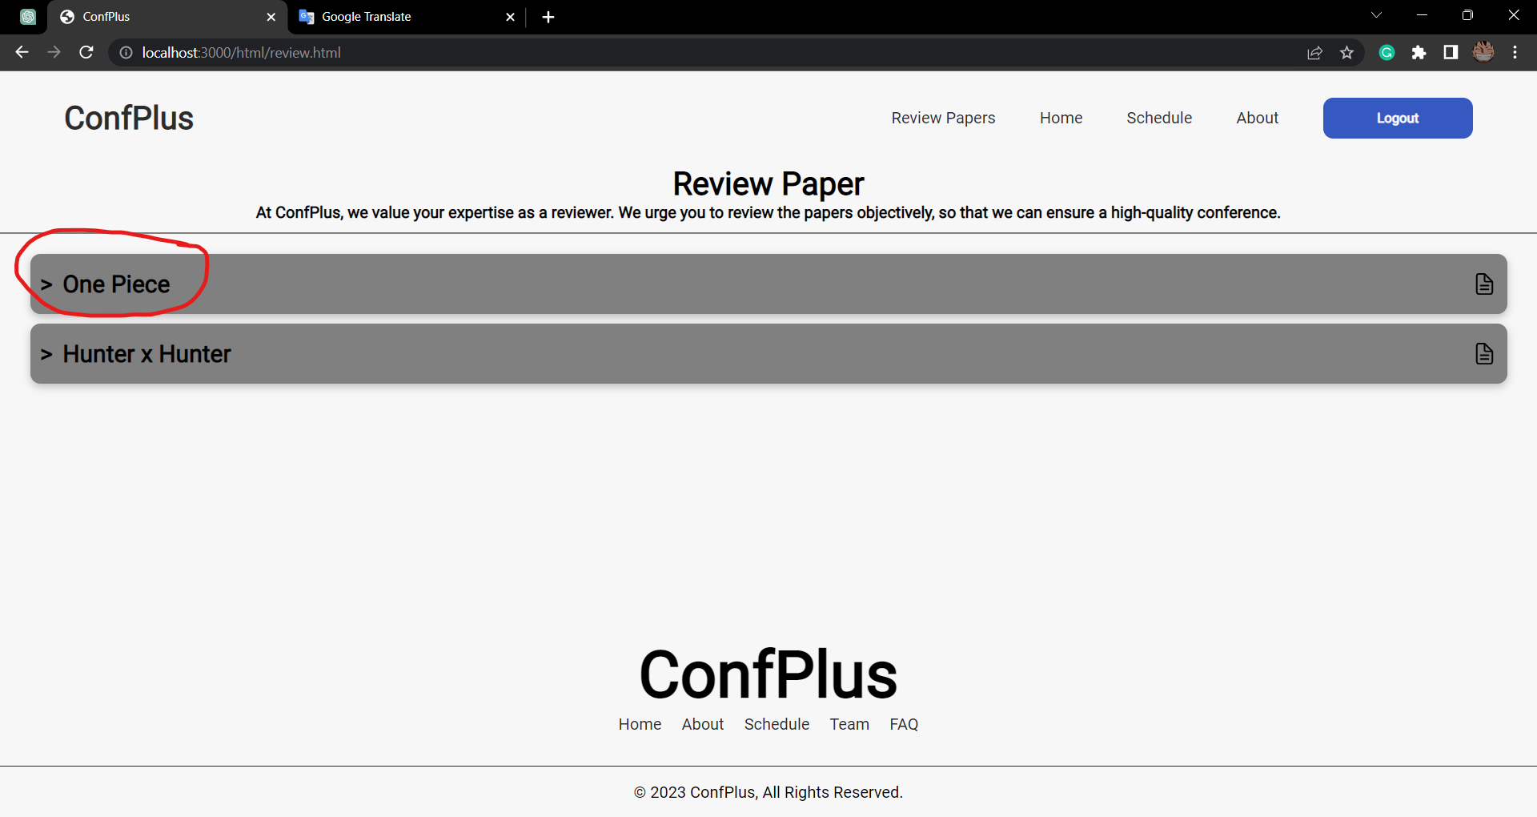

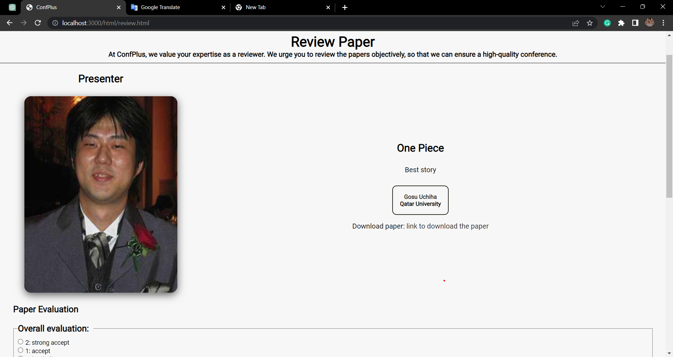

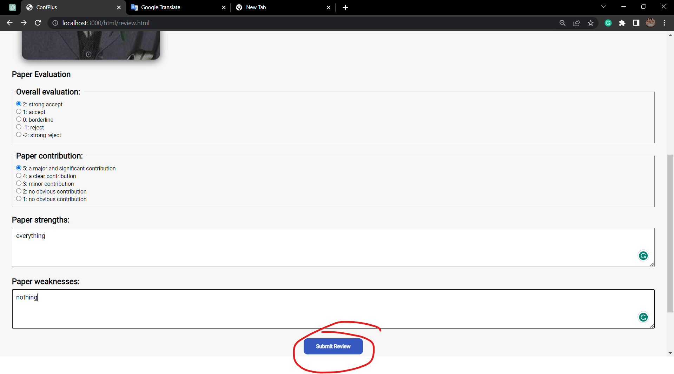

You will return to this review paper page:  
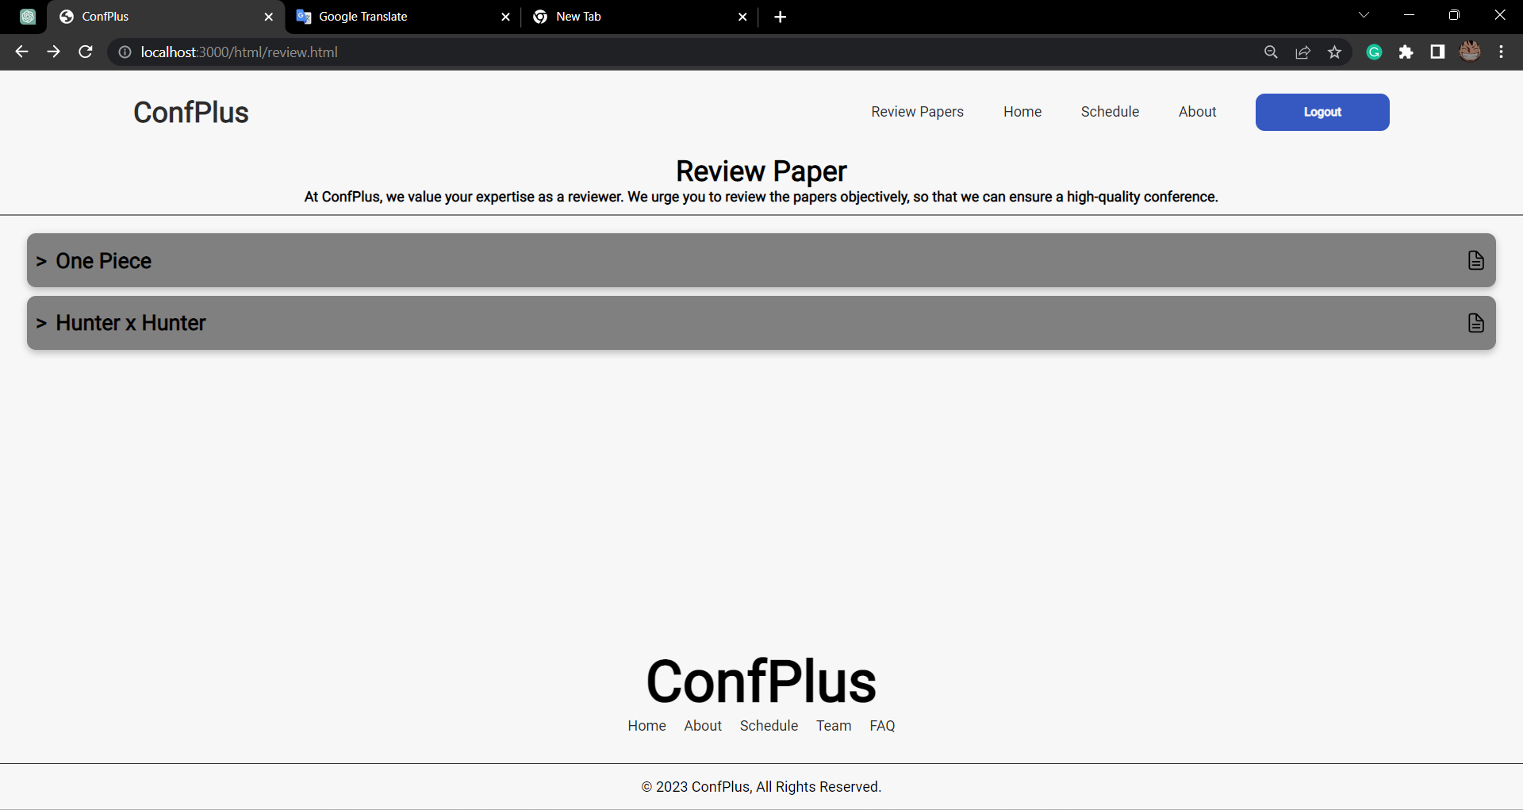

# Create/update conference schedule

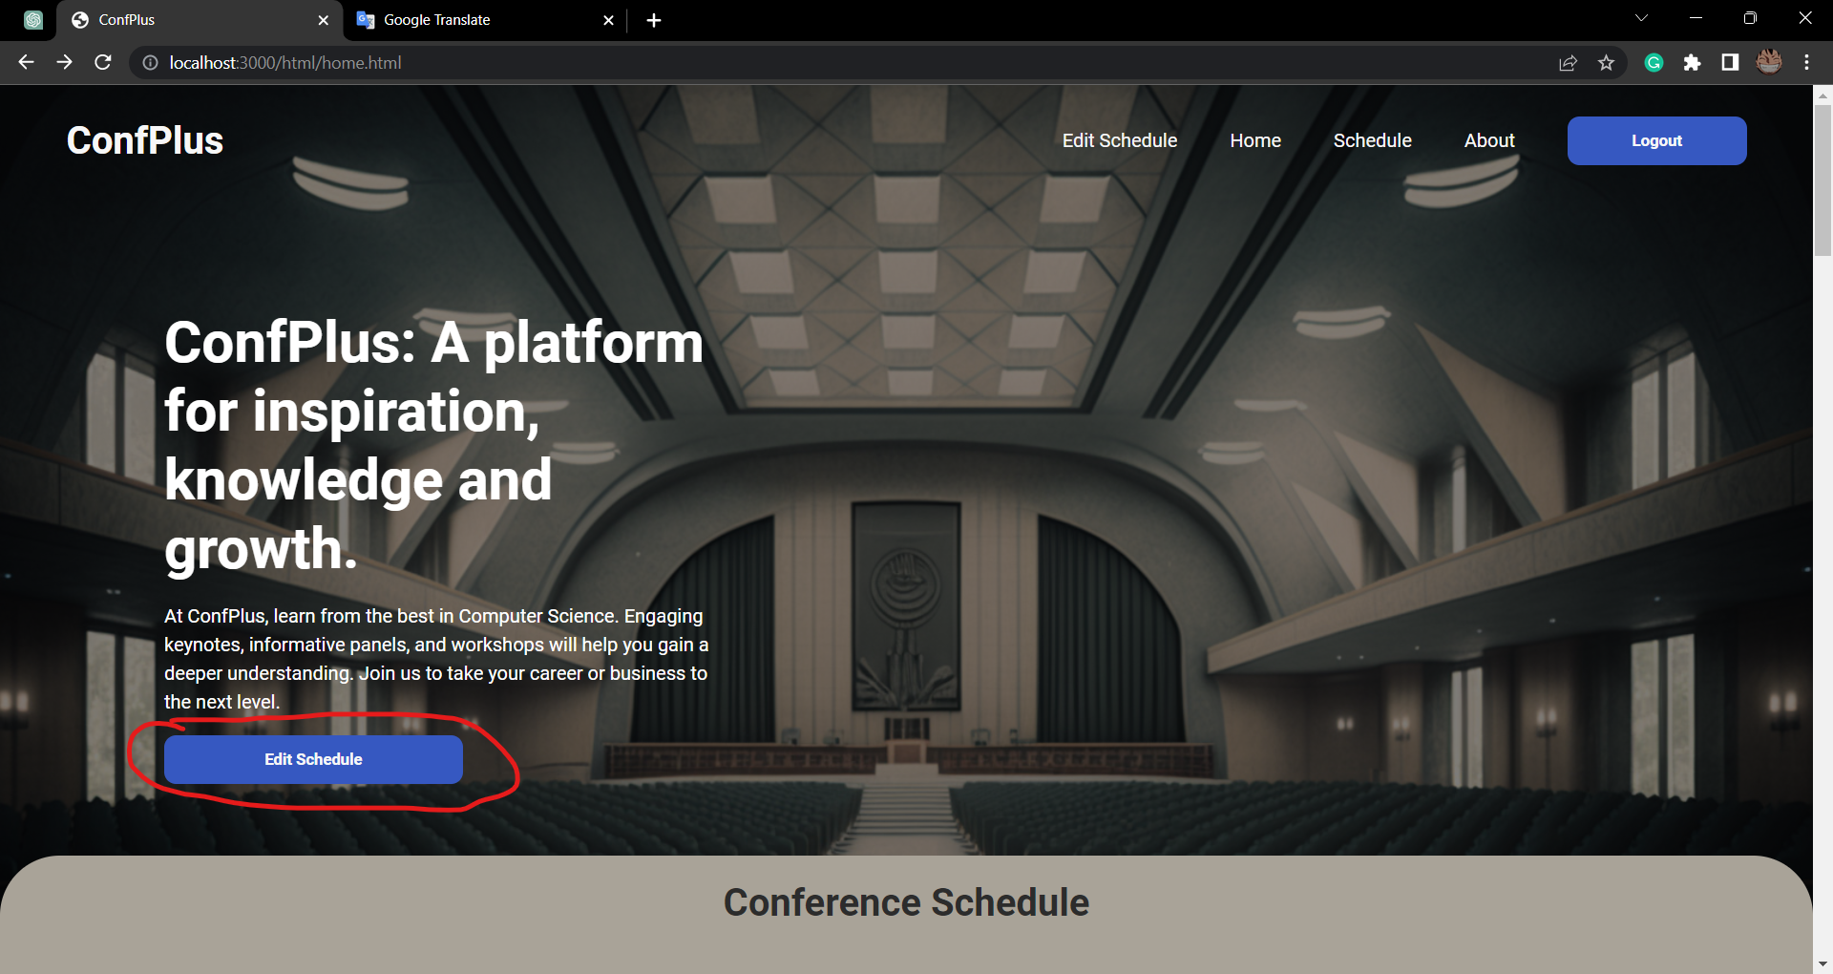  
  
If there is no session it will show this page:  
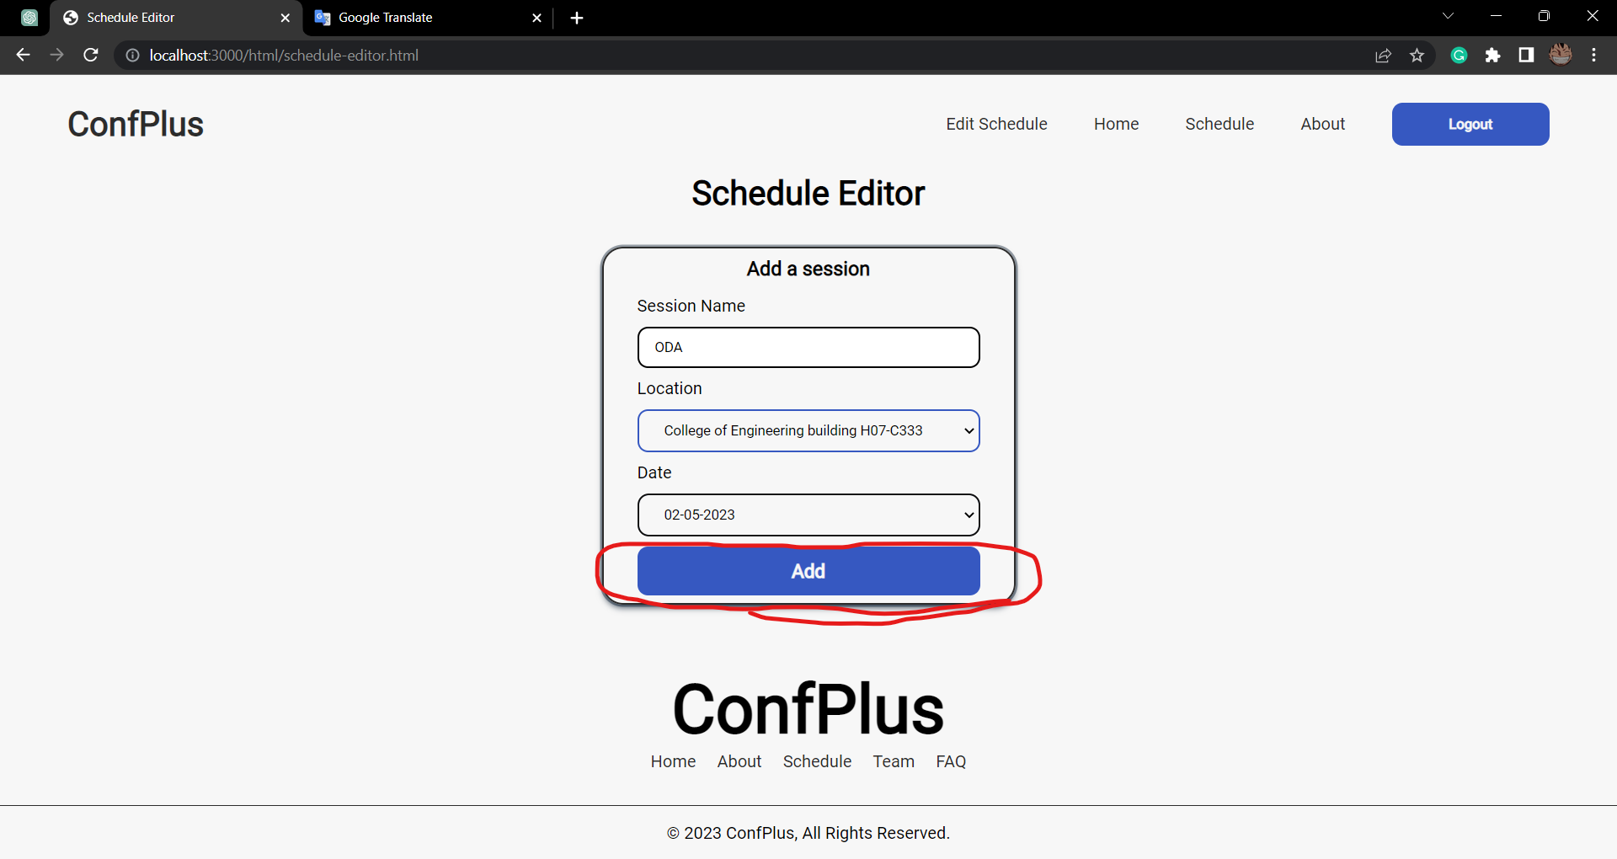

You can also add another session by clicking on the red circle:

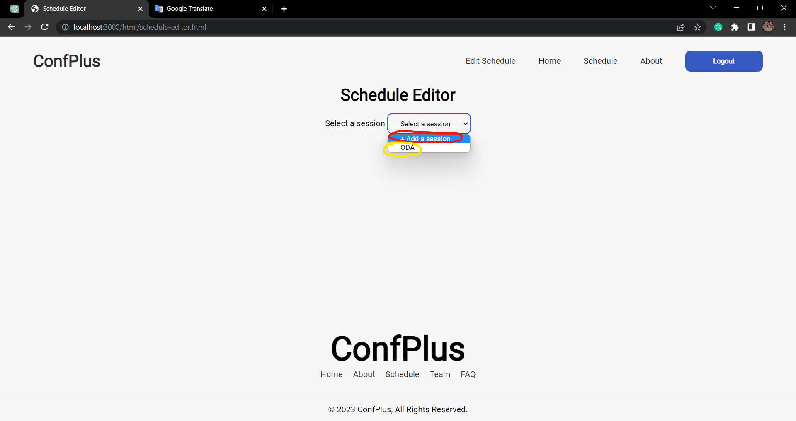

If you clicked on the yellow circle you will be able to modify the session:

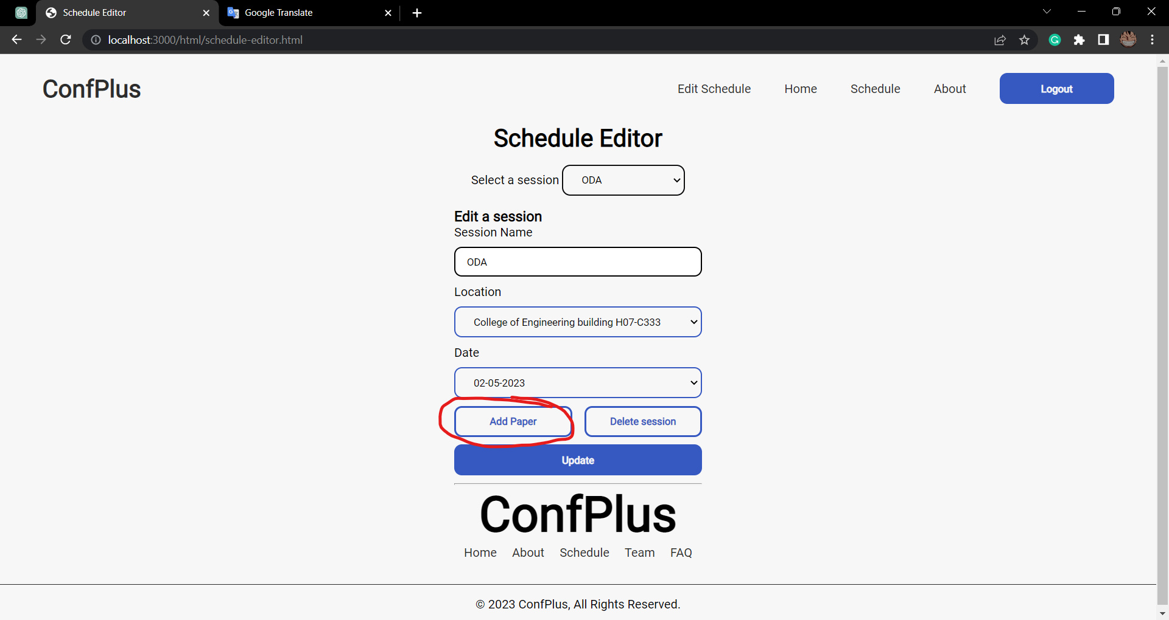

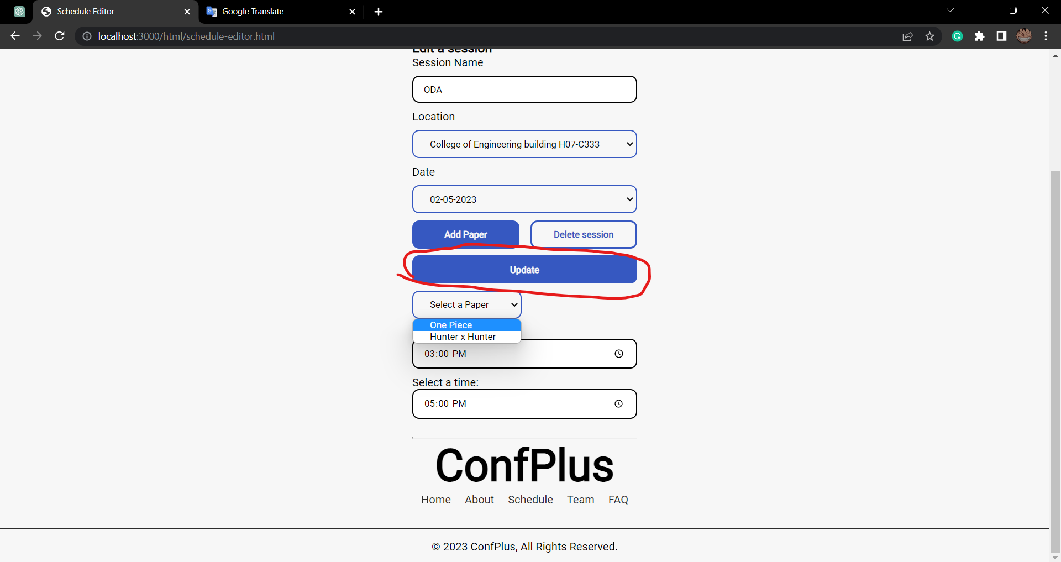

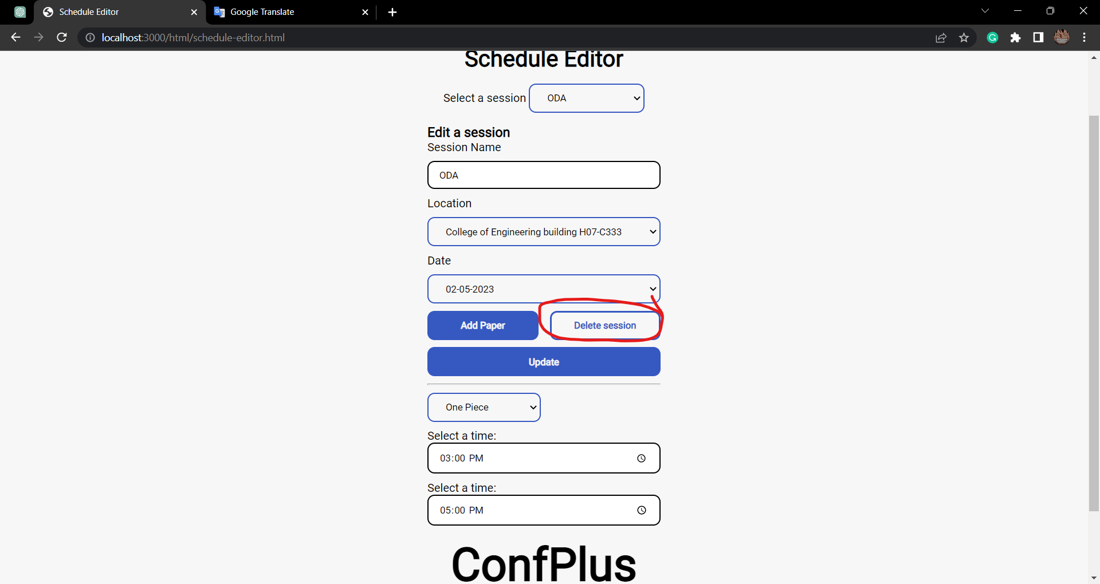

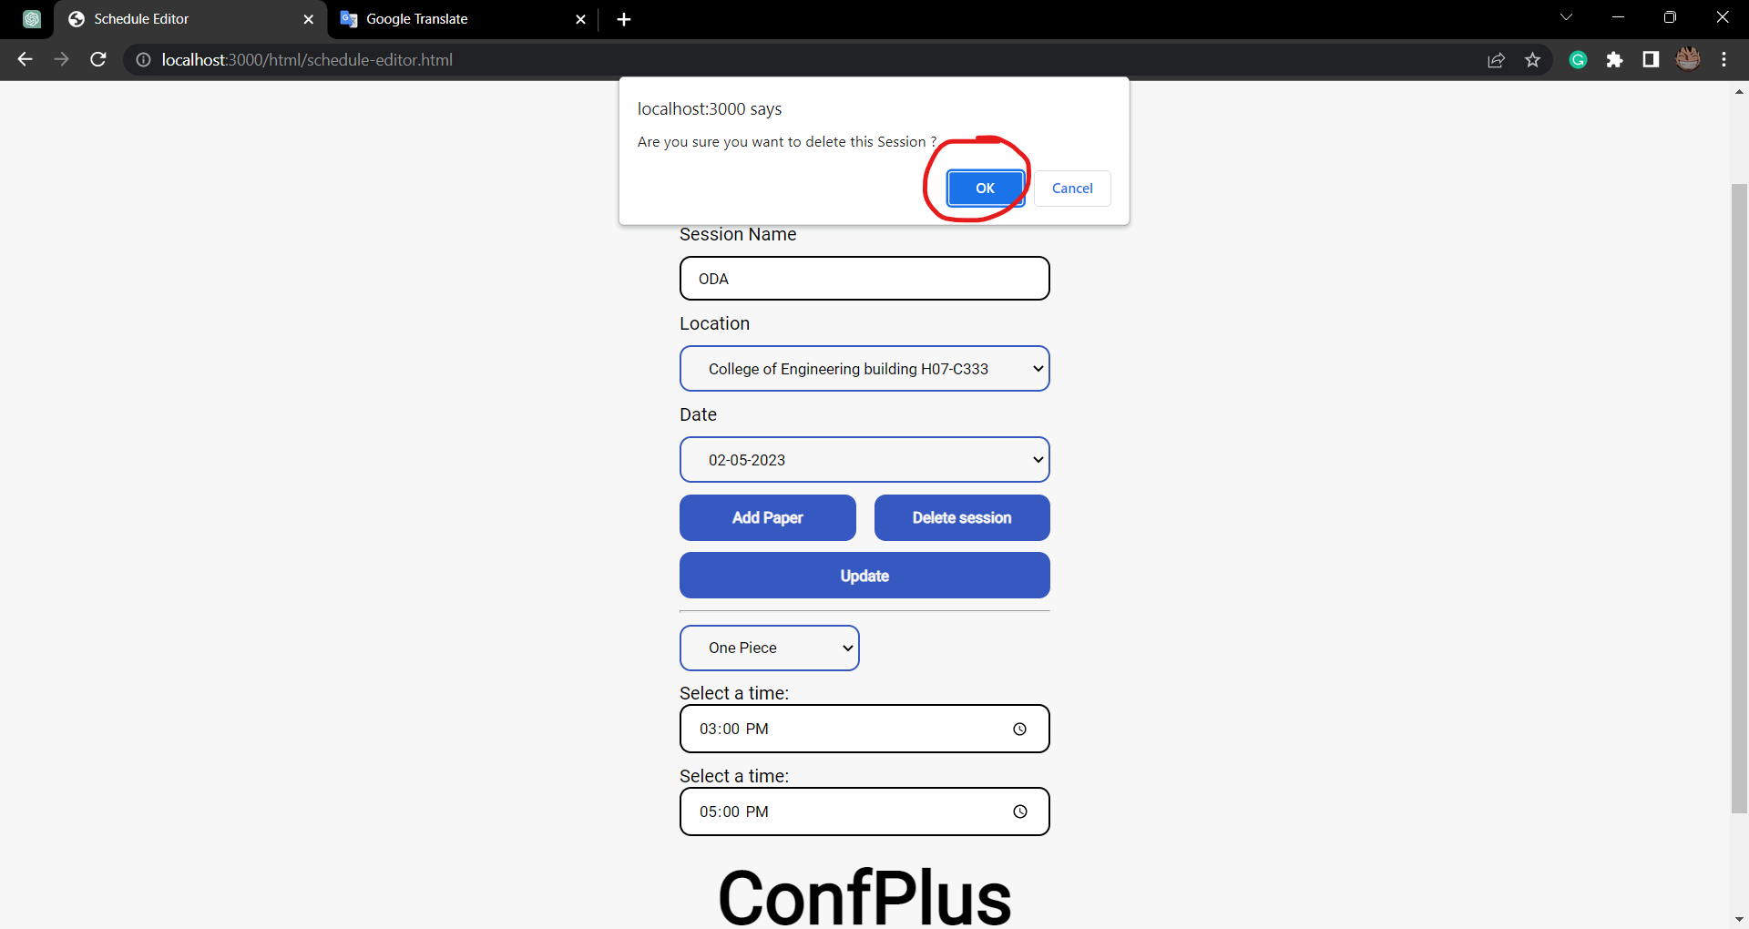

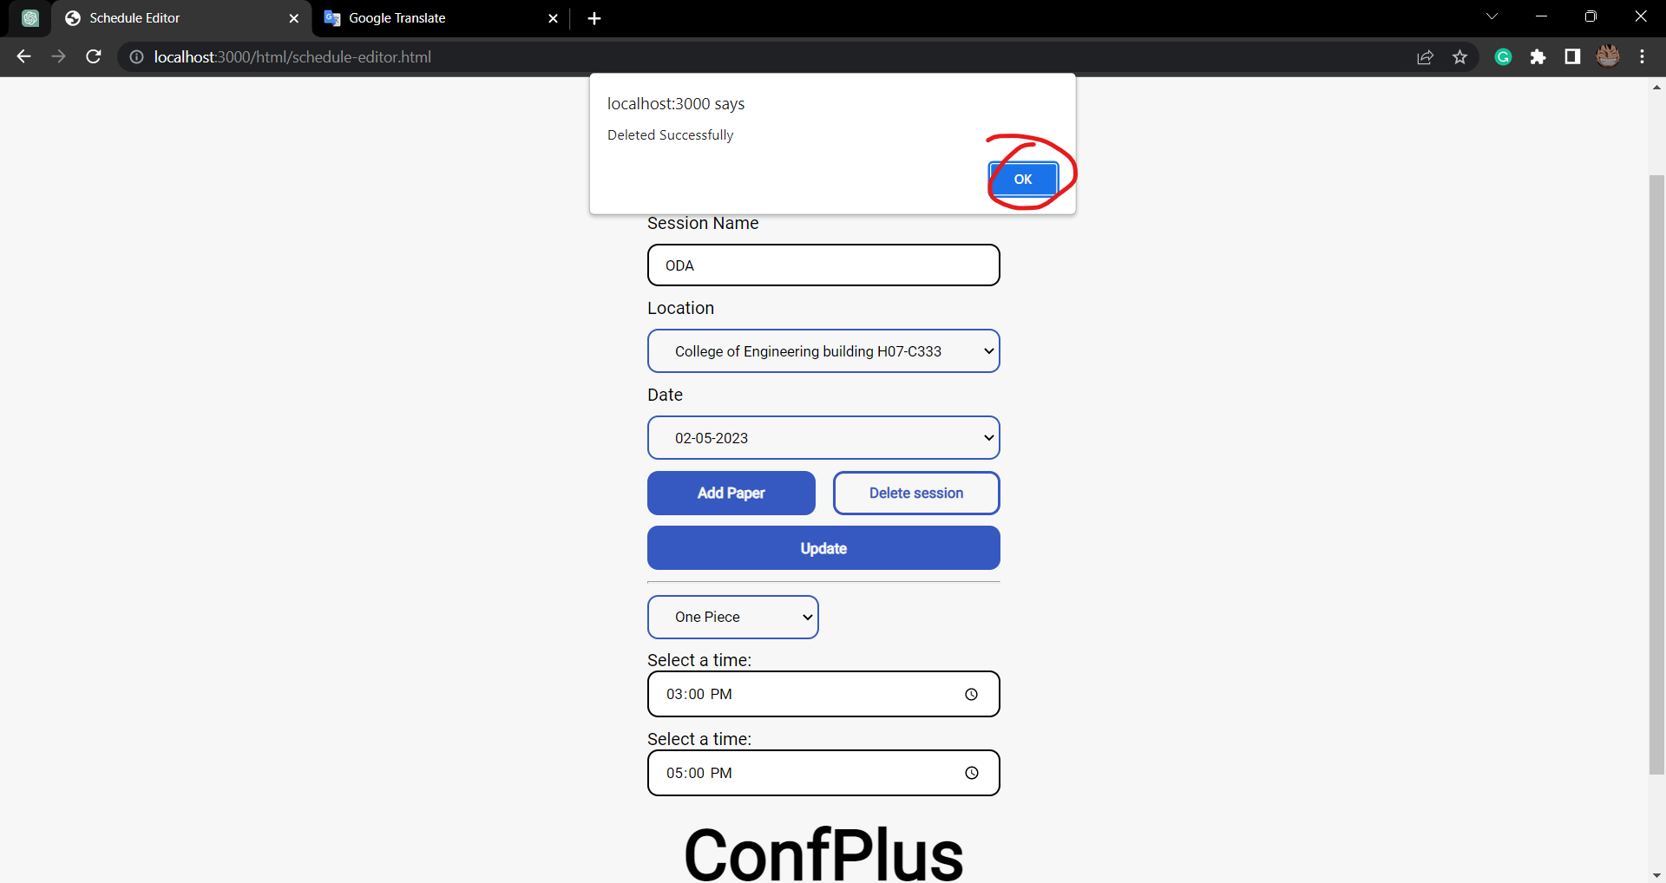

Because there is only 1 session it will return us to this page after delete:

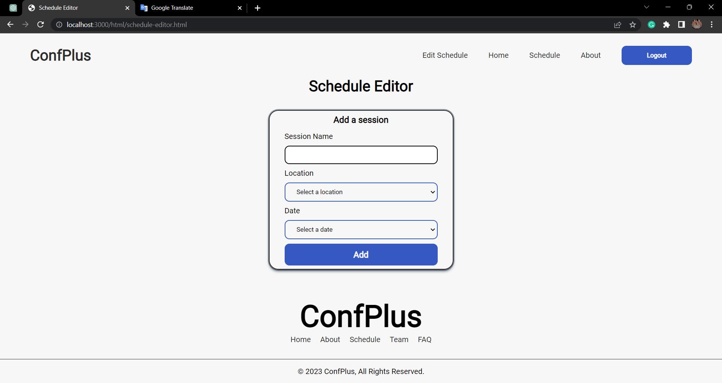

# Get conference schedule

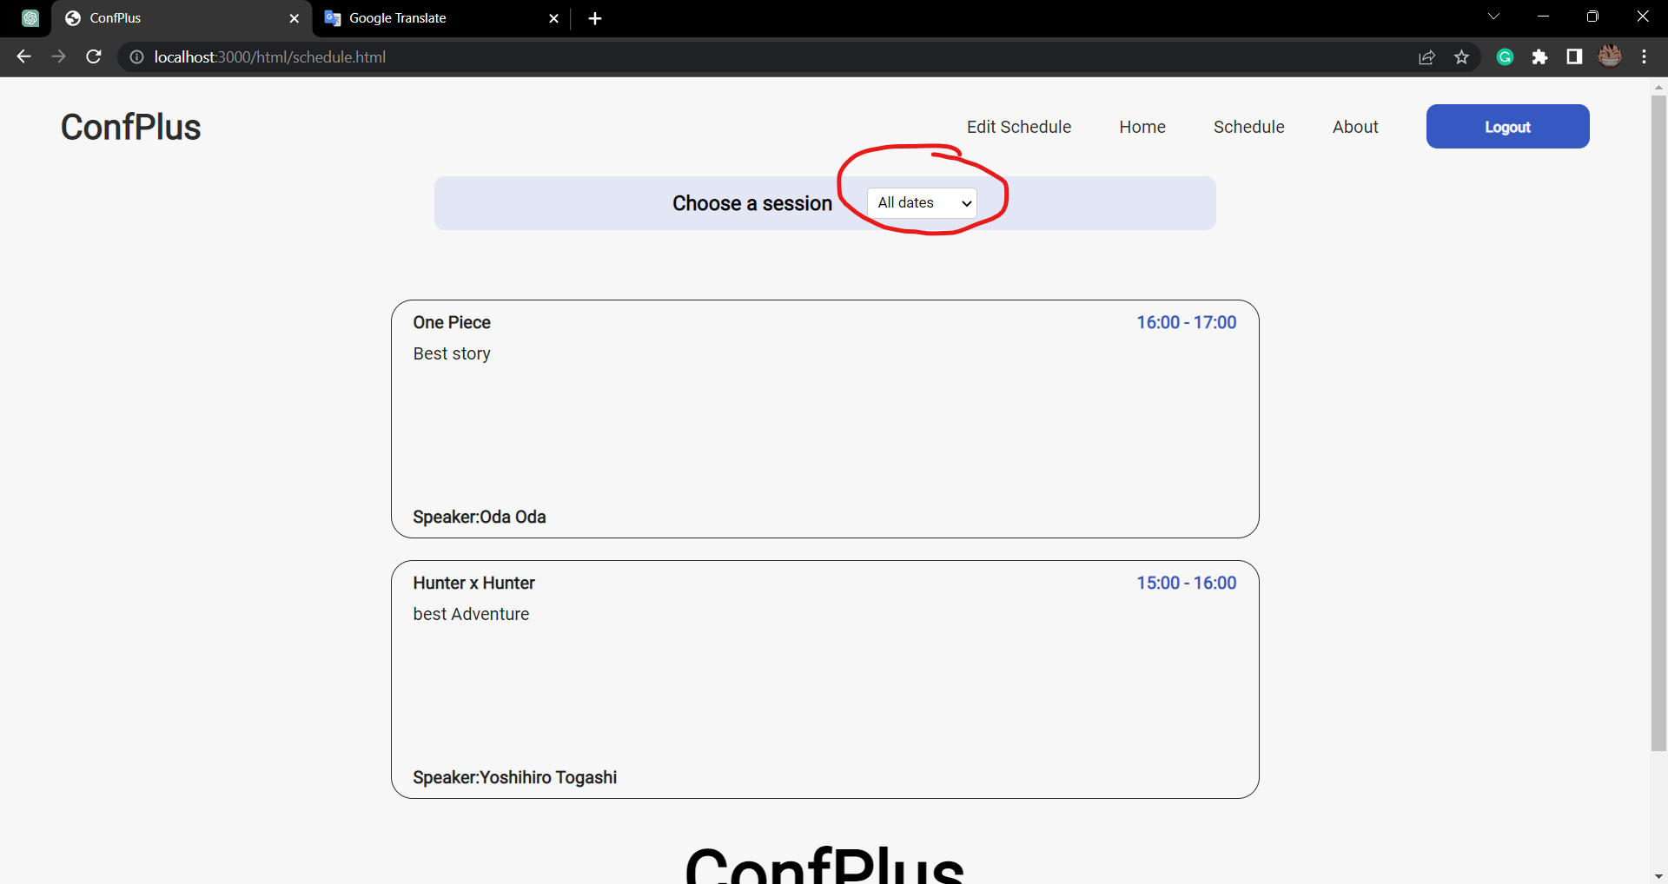

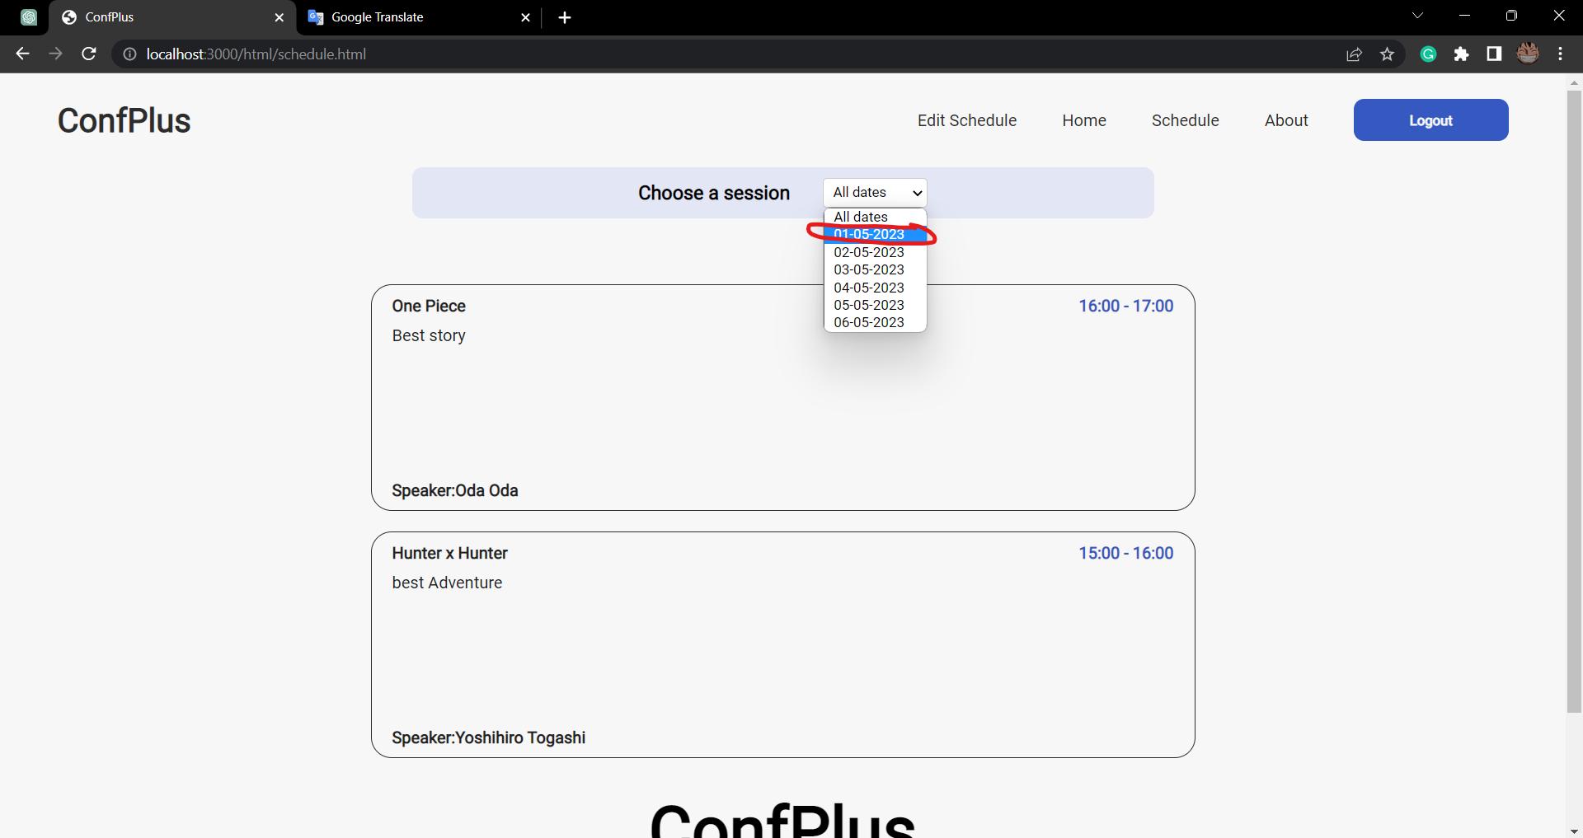

There is nothing in this date.

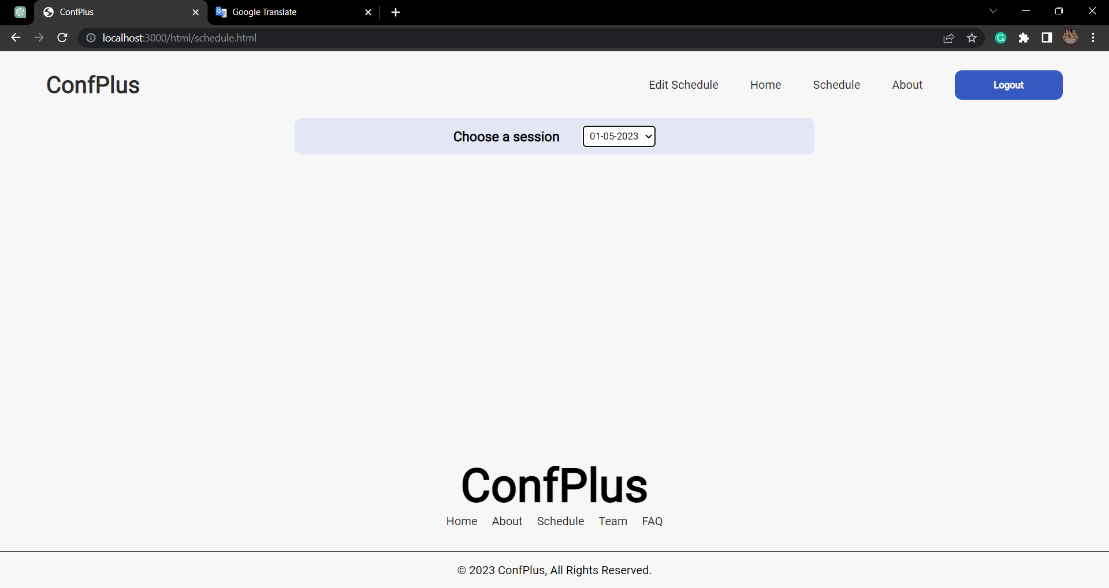

Mobile view:

Home Mobile  
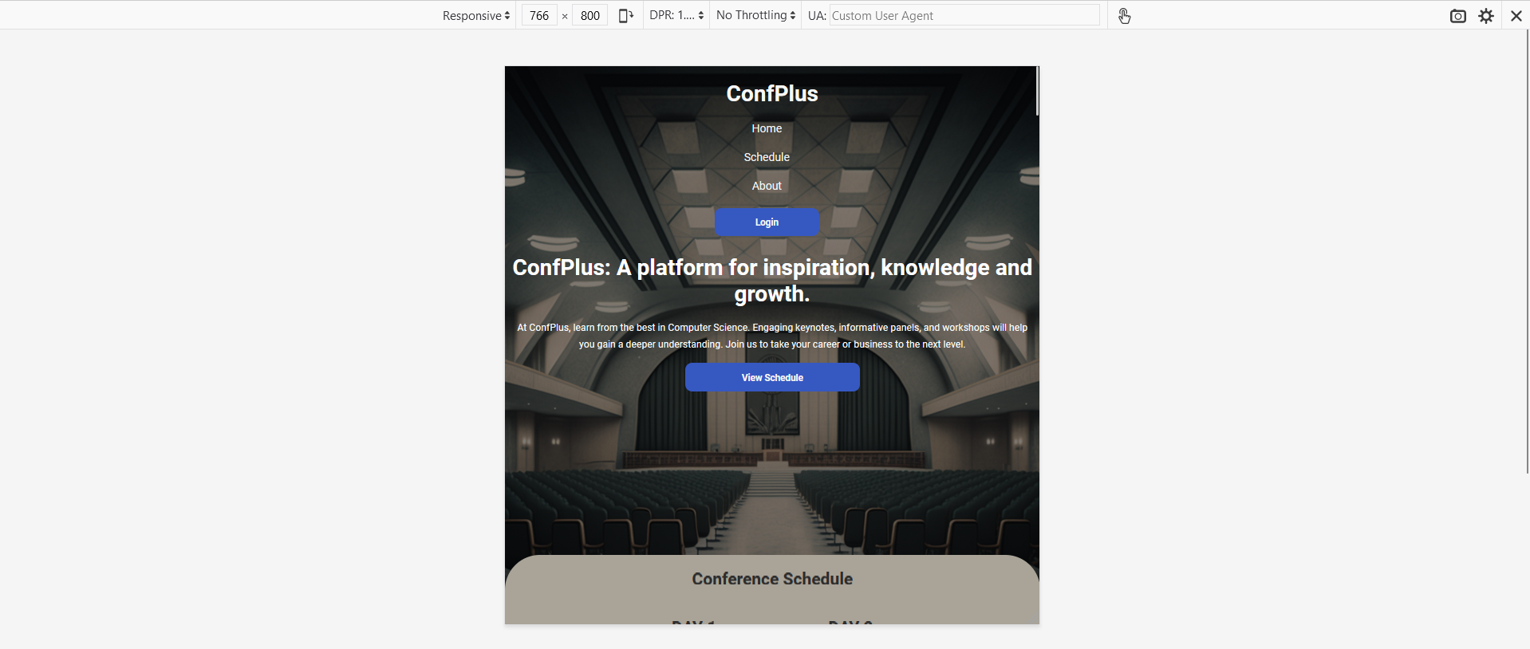

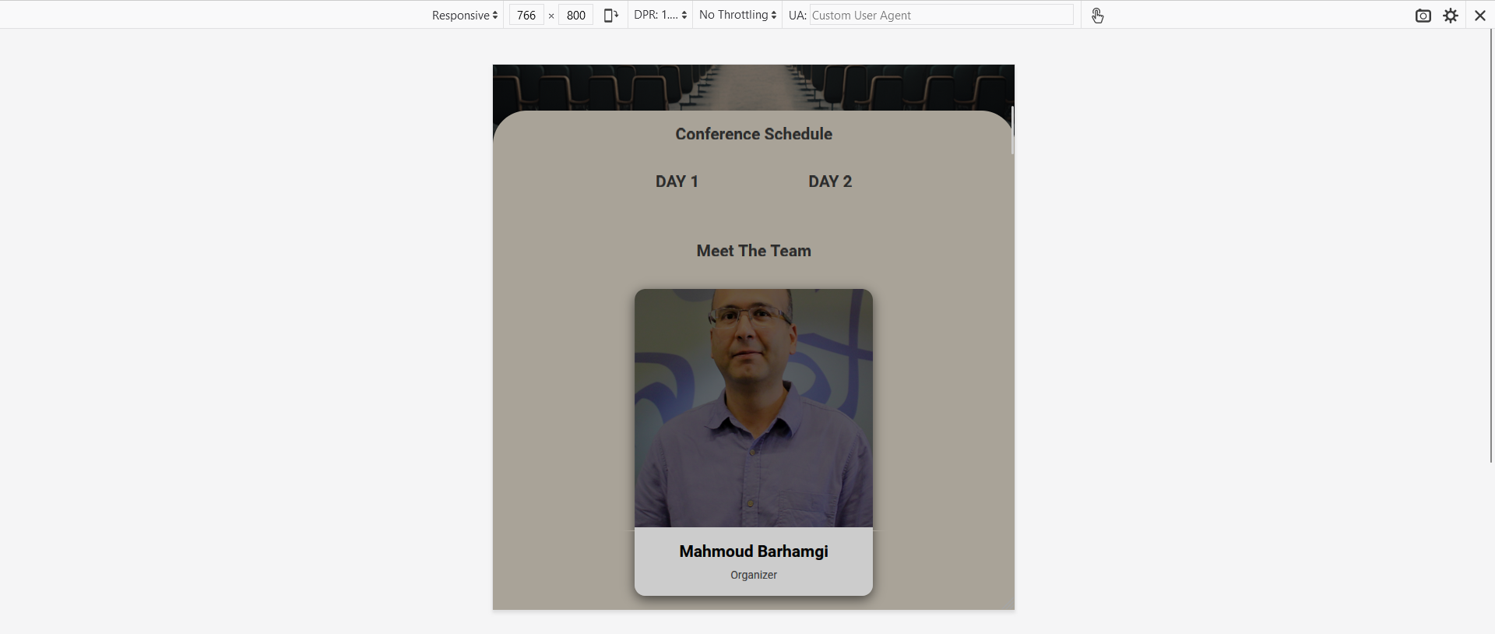

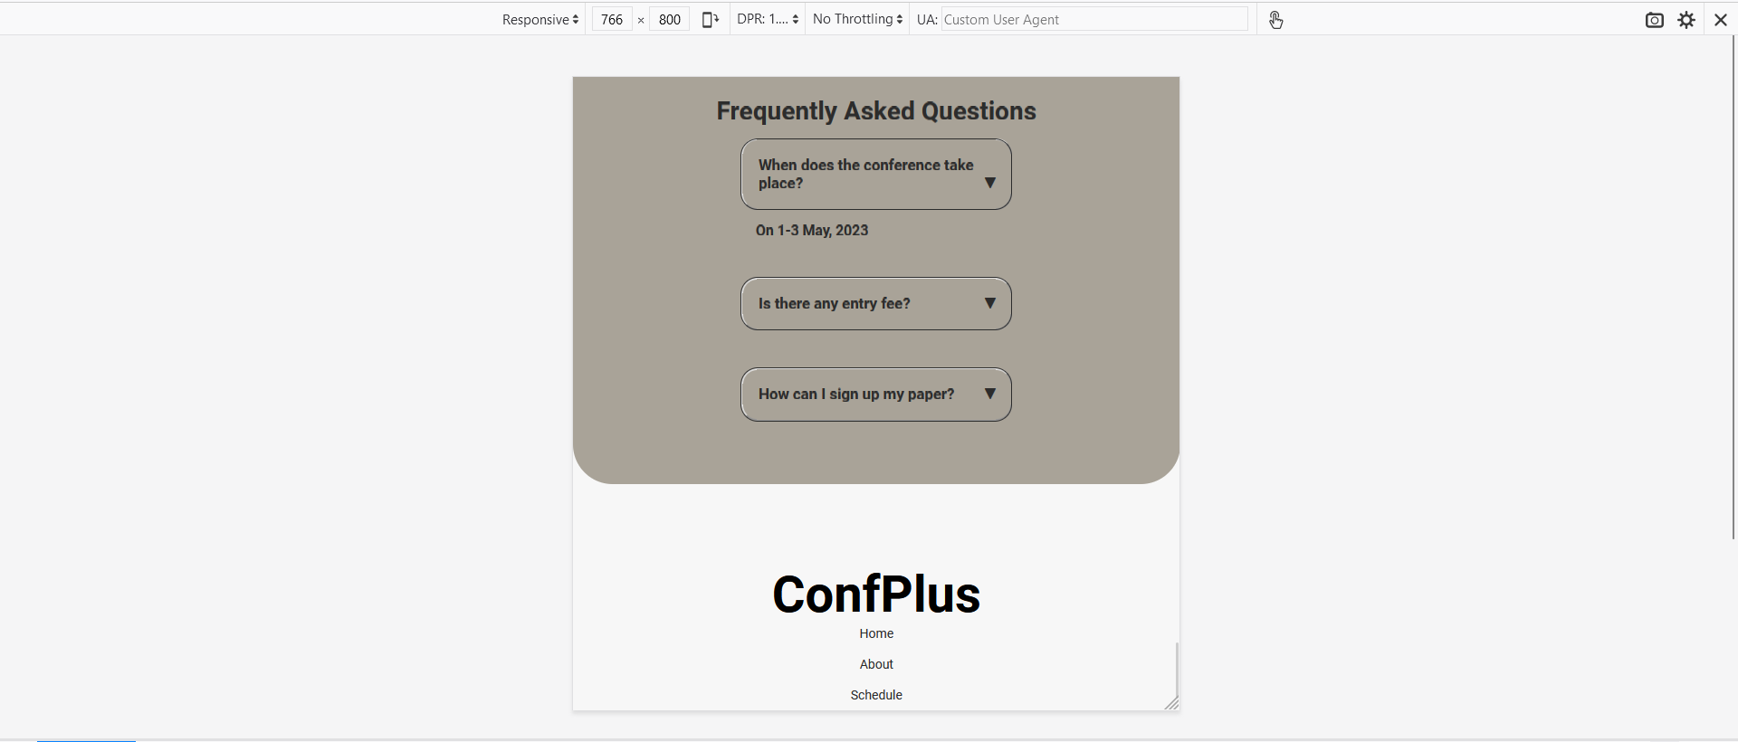

Edit schedule:

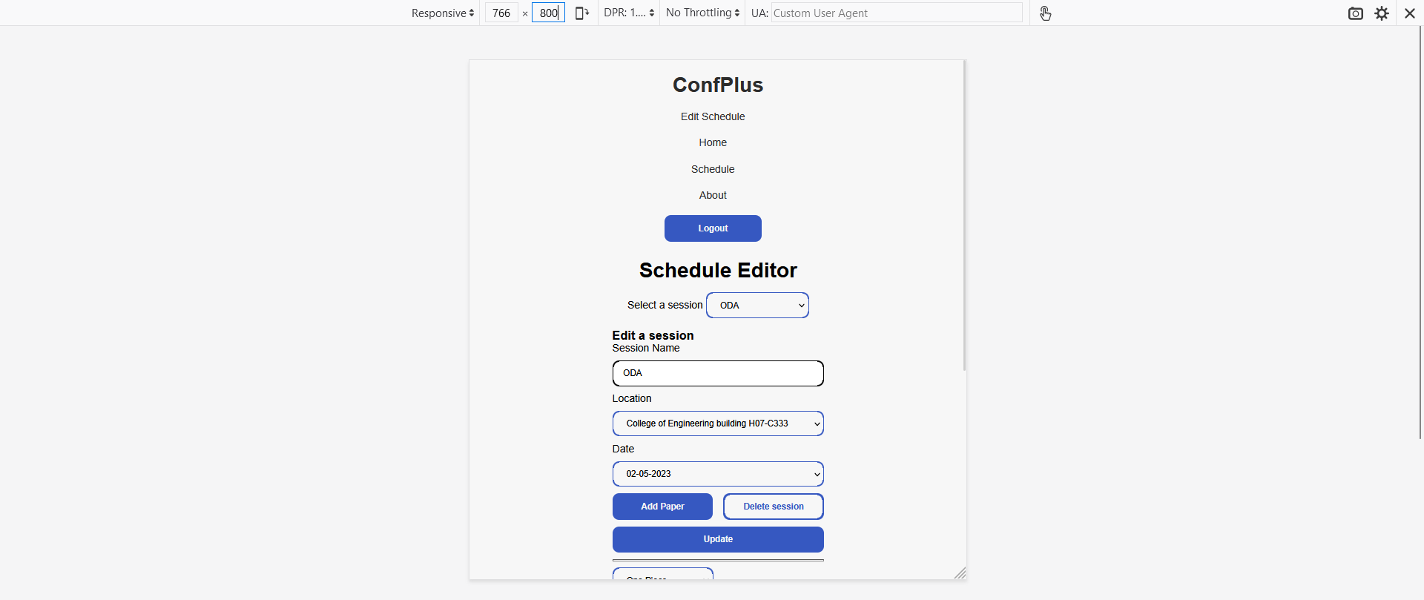

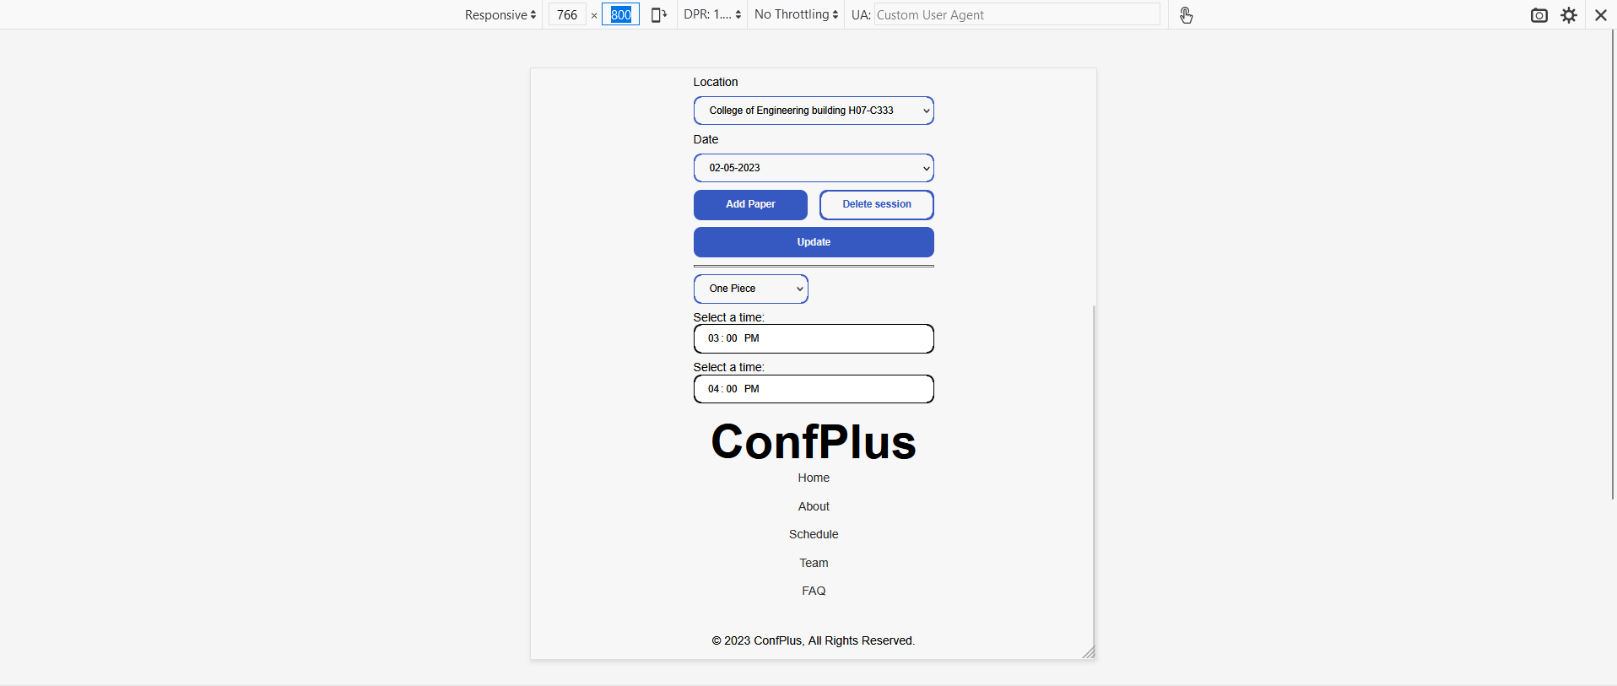

Schedule page:  
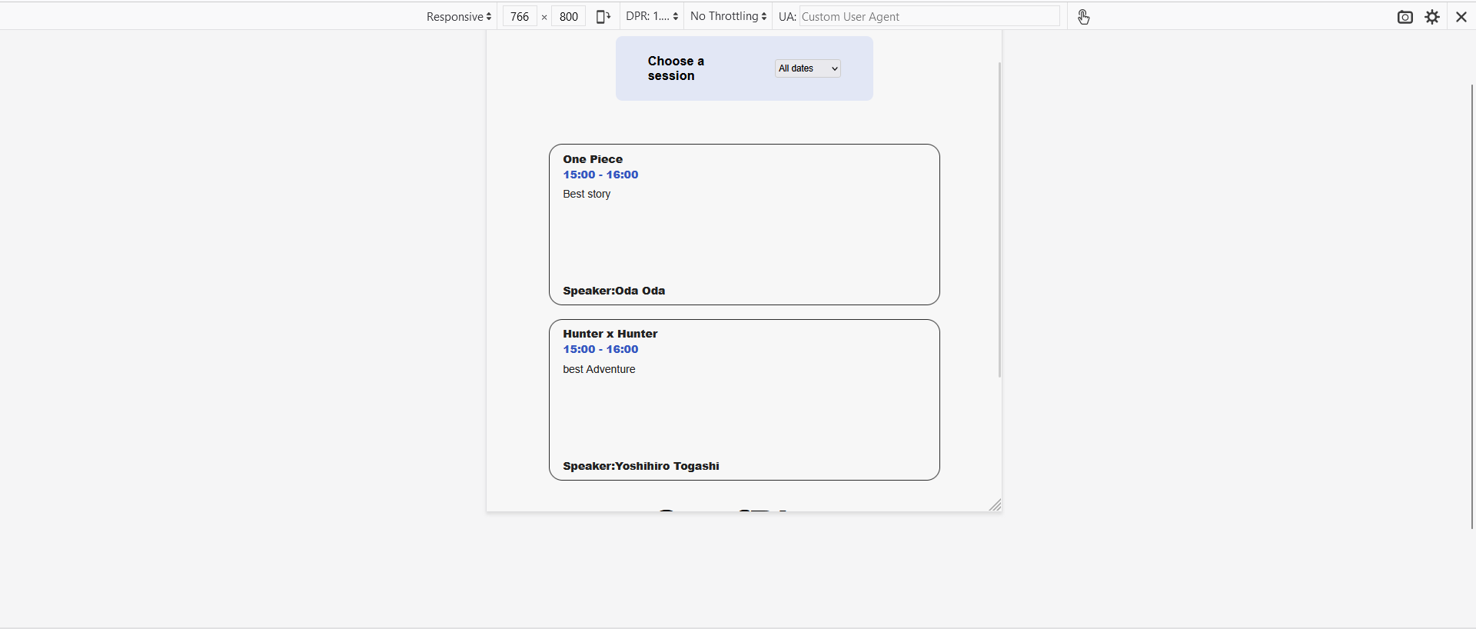

Review paper page:  
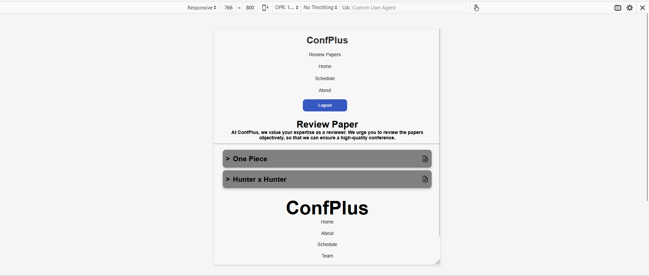

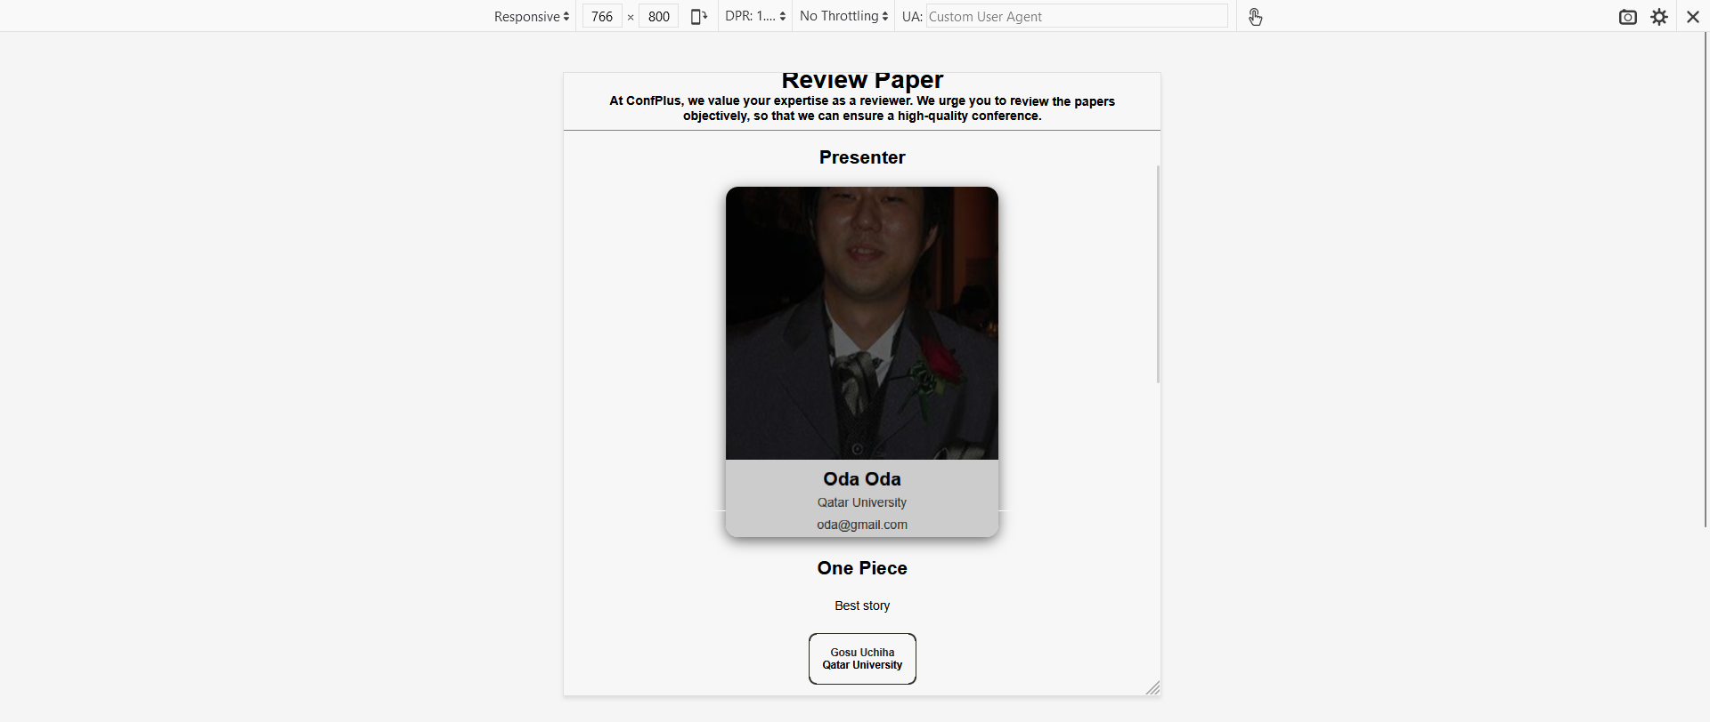

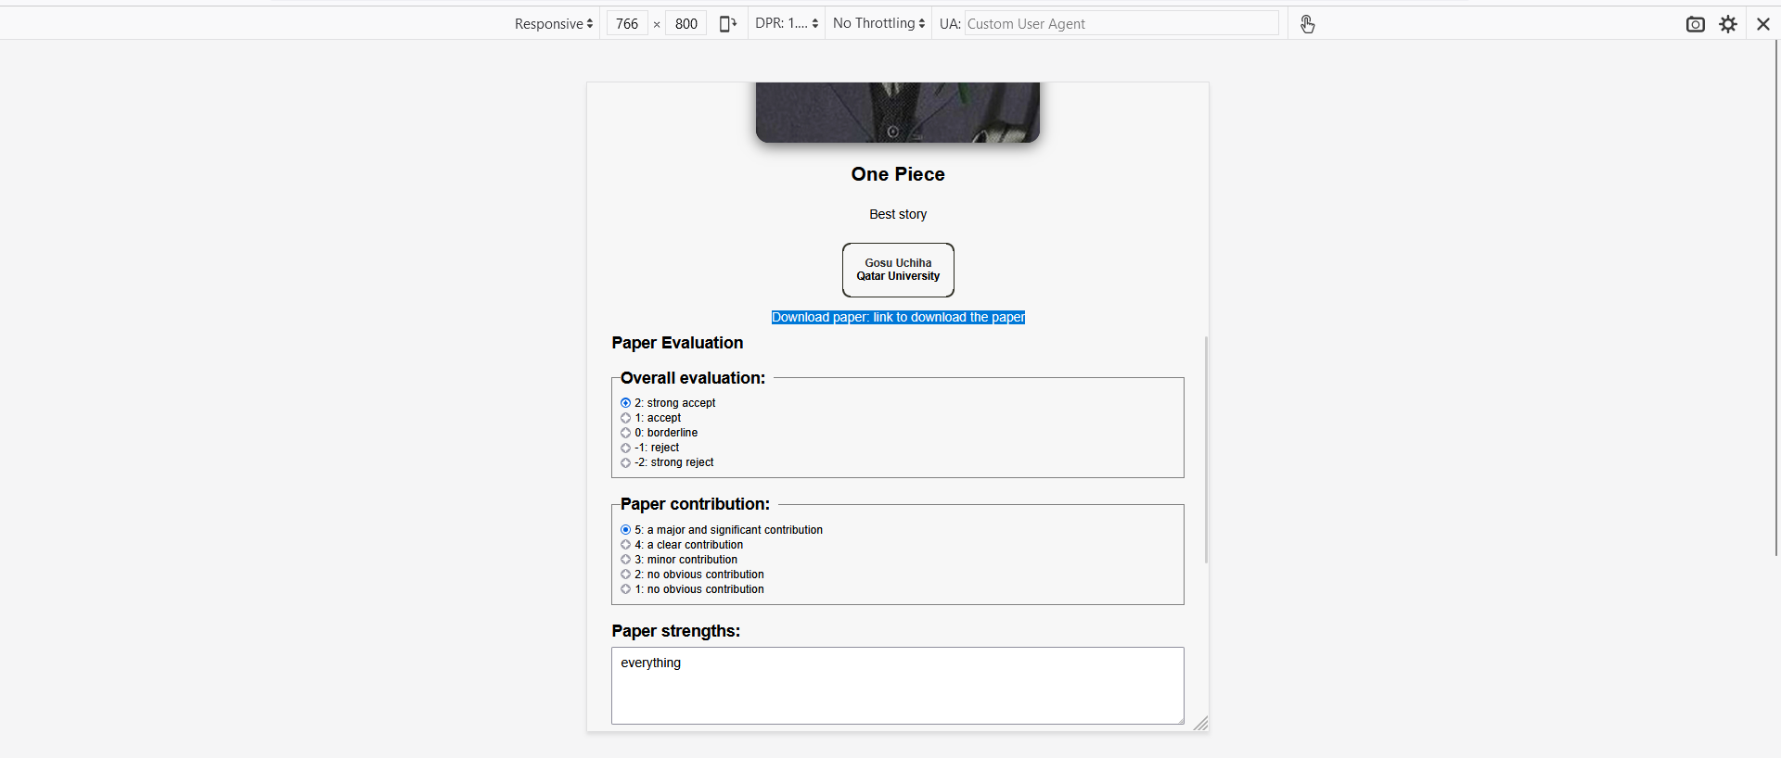

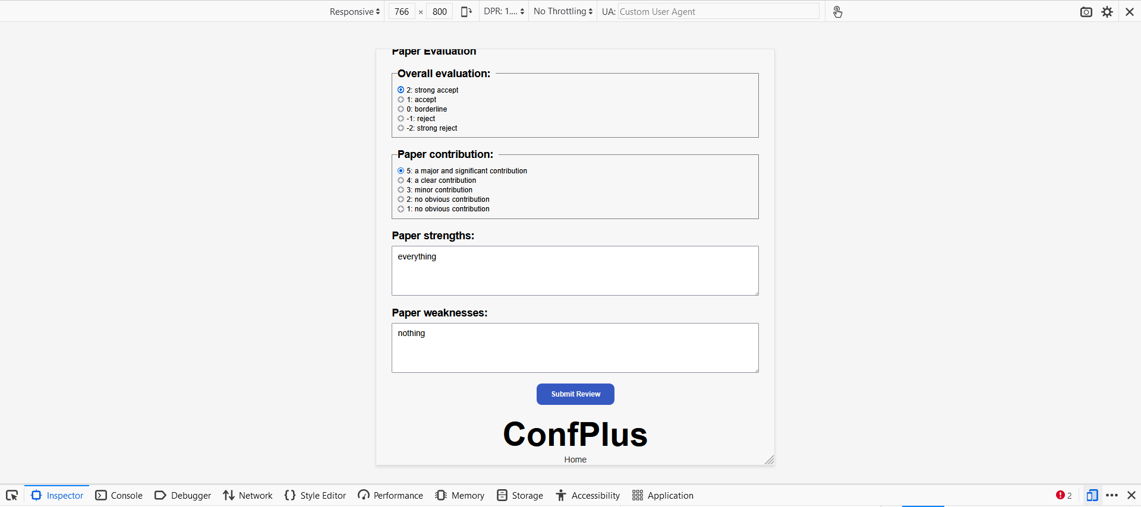

Submit Paper:  
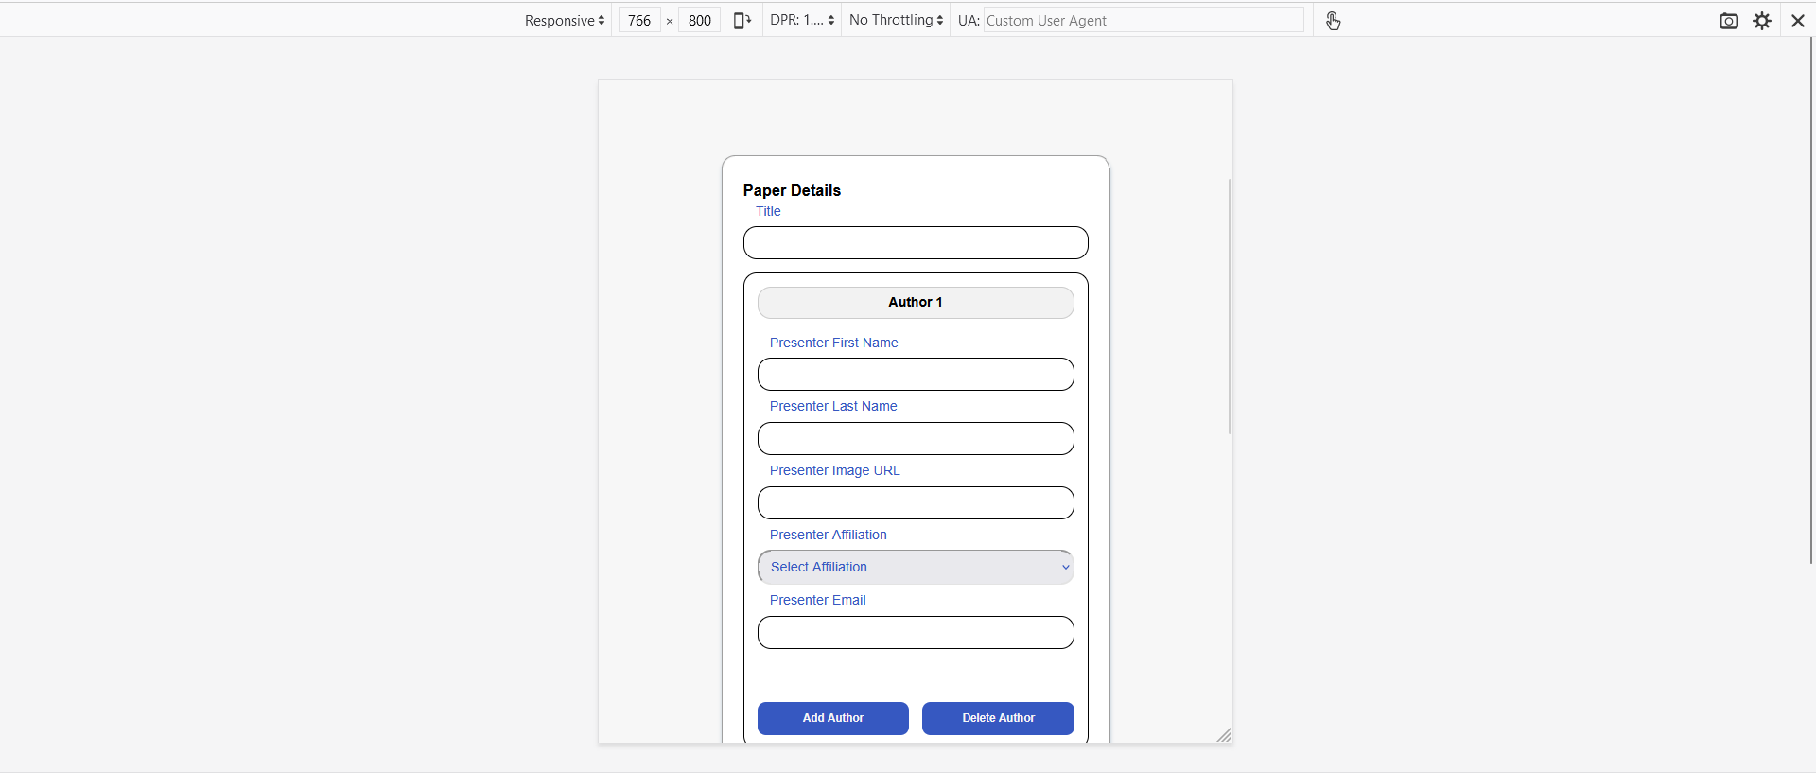

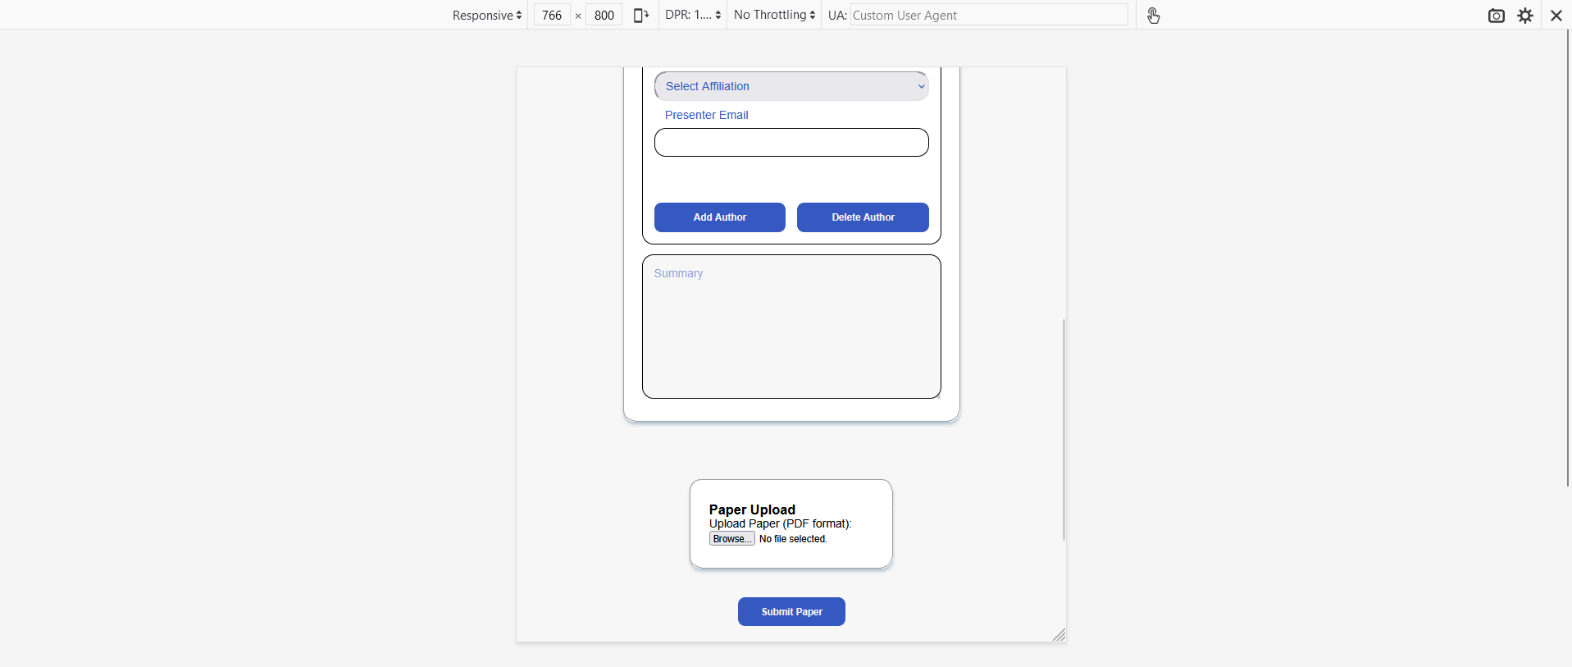

# Discussion of the project contribution of each team member

# Team member contributions

1. List of fully implemented use-cases / functionalities:

* Use Case 1: Login -> everything is working.
* Use Case 2: Submit a paper -> we don’t know if uploading the paper PDF to server working or not.
* Use Case 3: Review paper -> everything is working.
* Use Case 4: Create/update conference schedule -> everything is working.
* Use Case 5: Get conference schedule -> everything is working.

List of partially implemented use-cases / functionalities. Give the percentage of implementation.

none

List of use-cases that have not been implemented.

none

# Team coordination

|  |  |  |
| --- | --- | --- |
| 1. Team Member | Accomplished Tasks | Contribution Percentage |
| Ahmed Ahemd | Use case 2 Submit paper, report | 25% |
| Abdelbari Kecita | Schedule editor, Review paper | 25% |
| Mustafa Hussein | Home page, Submit Paper | 25% |
| Mohammed Al-Qeraisi | All CSS design, Home Page, Get Schedule | 25% |

Team coordination:  
 To collaborate efficiently, we used Discord as our primary communication tool, which allowed us to discuss project-related issues and share our screens to resolve problems in real-time. We also utilized GitHub to manage our codebase, which enabled us to work on different parts of the project simultaneously, and merge our changes seamlessly.